Granite River Labs
Addendum

For Hardware Setup and USB Type-C High-Speed Functional Test
Methods with GRL-USB-PD-FCB Type-C Functional Compliance
Board and GRL USB Type-C® Power Delivery Tester and
Analyzer (GRL-USB-PD-C2-EPR)

This material is provided as a reference to set up the hardware and perform USB Type-C High-Speed
Functional compliance testing using the Granite River Labs Type-C Functional Compliance Board
(GRL-USB-PD-FCB) and GRL-USB-PD-C2-EPR test controller as main equipment.
For software support, contact support@graniteriverlabs.com.

Documented based on Type_C Specification - Release 2.2
&
Documented based on Type_C Functional -Release 0.88

Table of contents

1-SCOPE OF THIS ADDENDUM
2-TEST MODES
2.1 Compliance mode.
2.2 Informational mode.
3-TEST/EQUIPMENT REQUIREMENTS
4-USB TYPE-C HIGH-SPEED FUNCTIONAL TEST SETUP
4.1 GENERAL TEST SETUP
4.1.1 For the non-captive cable UUT
4.1.2 For the captive-cable UUT
4.2 USB DATA VALIDATION TEST SETUP
5-USB DATA VALIDATION FUNCTIONAL TEST PROCEDURE
5.1 USB Power Delivery (PD) validation without Data validation support.
5.2 USB data validation.
5.2.1 Test Methods
5.2.1.1 Manual USB 2.0/3.1 Data Validation
6-TEST Case pop-ups.
7-CV tool use.
7.1 Test case 4.10.1 CV tool steps.
7.2 Test case 4.10.2 CV tool steps
7.3 Test case 4.10.3 CV tool steps.
7.3.1 USB 3.1 Device.
7.3.2 USB 2.0 Device.

- Scope of this Addendum

This Addendum serves as the supplementary documentation to connect the GRL-USB-PD-FCB
Type-C Functional Compliance Board to the GRL-USB-PD-C2-EPR USB Type-C Test Controller and
unit-under-test (UUT) for USB Type-C High-Speed Functional compliance testing. This will be
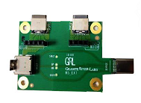
followed by Methods of Implementation (MOI) procedures to perform manual testing using the GRL_Browser_App software and test setups.

Below describes the GRL-USB-PD-FCB Type-C Functional Compliance Board, which comprises the
following test fixture:
• GRL-HS-EXT Fixture – Extension fixture for GRL-USB-PD-C2-EPR
test controller, used to control VBUS and CC lines between
connected devices without interfering the high-speed lines between
Type-C input/output connectors.

2-TEST MODES:

Open the browser application and once the connection is established in Connection tab. Please move to Product capability tab. In Product capability tab, User is requested to enter the project name. Once the project name is entered user will be requested to select the Mode following are the two modes:
2.1 Compliance mode
2.2 Informational mode
(Brief on modes, please have a look on 5.1 Product Capability refer to the browser app user documentation download at
https://graniteriverlabs.com/download-center/.)

2.1 Compliance mode:
The Mode is used for a Certification run. In this mode user can load the VIF and select cable type and move to Test Config Tab.
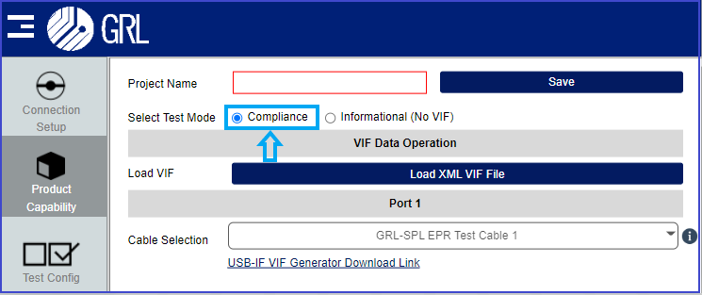
Fig: compliance test option

In the Test Config tab, USB-C Functional Test MOI is selected. Tester has some configuration on the selected Test cases. So, by default Some fields like USB data validation will be updated with the information from the loaded VIF. User have an option
- UUT embedded Hub & UUT battery connected as per CTS
- To enable/ disable USB data validation.
- To enter the number of USB-type_C port in UUT.
- To enter the number of USB Mirco-B/Type-B or Type-A port in UUT.
User must make sure to check the setup Image before start of the execution for correct Hardware connection.
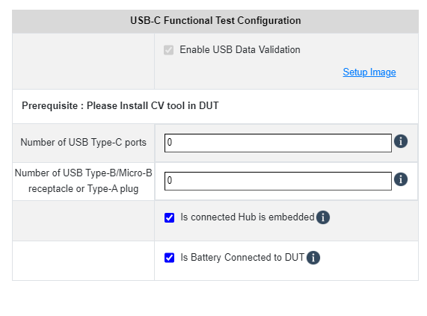
Fig: Test Configuration - Compliance mode

2.2 Informational mode:
The Mode is used for Informational only, in this mode user can create new VIF with Device data, Ran the Test case without loading VIF, Generate VIF using VIF Generator and Test Config can be changed based on the user needs for both port 1 & 2. (USB data validation can be Enabled/disabled manually).
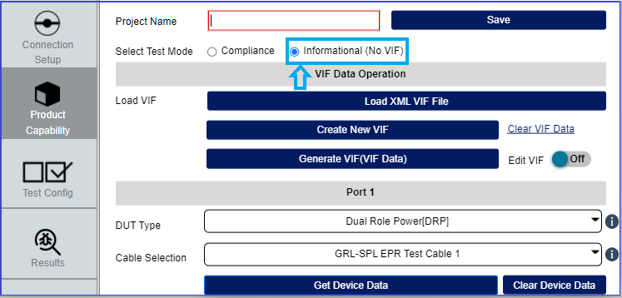
Fig: Informational mode

In the Test Config tab, USB-C Functional Test MOI is selected. Tester has some configuration on the selected Test cases. So, User have an option to update the below fields:
- Is UUT battery Connected
- Is UUT embedded Hub
- USB data validation
- To enable/ disable USB data validation.
- To enter the number of USB-type_C port in UUT.
- To enter the number of USB Mirco-B/Type-B or Type-A port in UUT.
User must make sure to check the setup Image before start of the execution for correct Hardware connection.
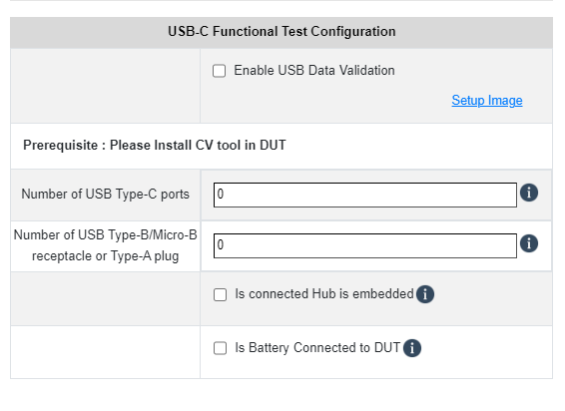
Fig: Test Configuration - Informational mode

3-Test/Equipment Requirements:
For purchase or information of the following items, contact info@graniteriverlabs.com.

• GRL-USB-PD-FCB Type-C Functional Compliance Board package (GRL-HS-EXT test fixture)

• GRL-USB-PD-C2-EPR USB Type-C test controller

• 2 x GRL Special (GRL-EPR-SPL) Type-C VCONN passthrough test cables (GRL-USB-PD-STC)
[Note: GRL recommends using 3 x GRL-EPR-SPL cables for the non-captive cable UUT setup.]

• Good-known device (GKD) with USB Type-C Power Delivery Data port (computer or phone,
USB-IF compliant) [Note: GRL recommends using the Google Pixel 3 phone as GKD.]

• CV tool software (USB 3 gen) in HOST laptop can be better for execution. Tool can be downloaded from USBIF website.

4-USB Type-C High-Speed Functional Test Setup
This section describes the hardware connects and procedures to set up the equipment and fixture for
USB Type-C High-Speed Functional compliance testing. Below are the different types of test setups:

• General test setup ‒ Applicable for all type of UUT’s.
• High-Speed Validation test setup ‒ Applicable only when USB data validation is enabled.

Make sure to follow all the steps as described below before testing the test execution.
For details on using the C2 / C2 EPR software, refer to the browser app user documentation in
https://graniteriverlabs.com/download-center/.

4.1 General Test Setup
4.1.1 For the non-captive cable UUT:
Connect the UUT directly to Port 1 of the GRL-USB-PD-C2-EPR test controller using the GRL-EPR-SPL cable,
as shown in below fig.
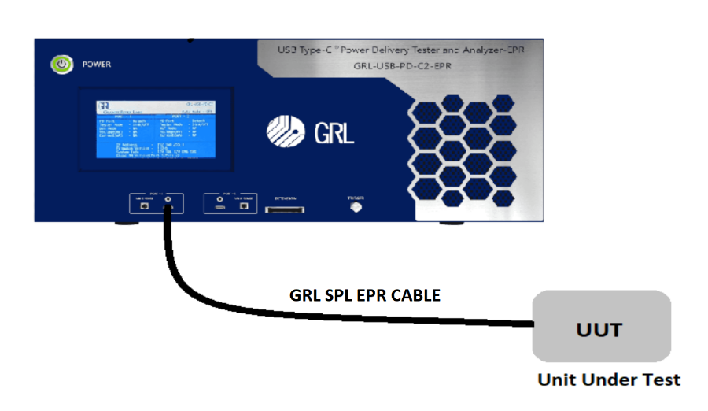
Fig: GENERAL TEST CONNECTION SETUP ‒ FOR NON-CAPTIVE UUT

4.1.2 For the captive-cable UUT:
Connect the UUT directly to Port 1 of the GRL-USB-PD-C2-EPR test controller using a captive cable, as
shown in figure.
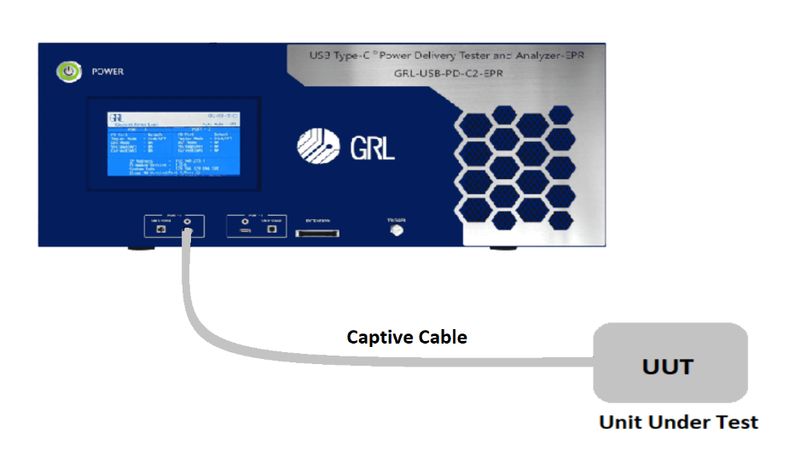
Fig: GENERAL TEST CONNECTION SETUP ‒ FOR CAPTIVE-CABLE UUT

4.2 USB Data Validation Test Setup
Figure below shows the connection setup diagram for the following steps.
1. Connect Port1 and Port2 of the GRL-HS-EXT fixture to Port 1 and Port 2 of the GRL-USB-PD-
C2-EPR test controller respectively using the GRL-EPR-SPL cable.
2. Connect the good-known device (GKD) to the plug side of the GRL-HS-EXT fixture.
3. Connect the UUT (if non-captive cabled) to the Receptacle port of the GRL-HS-EXT fixture
using the GRL-EPR-SPL cable. (If captive cable connects it directly to Receptacle port)

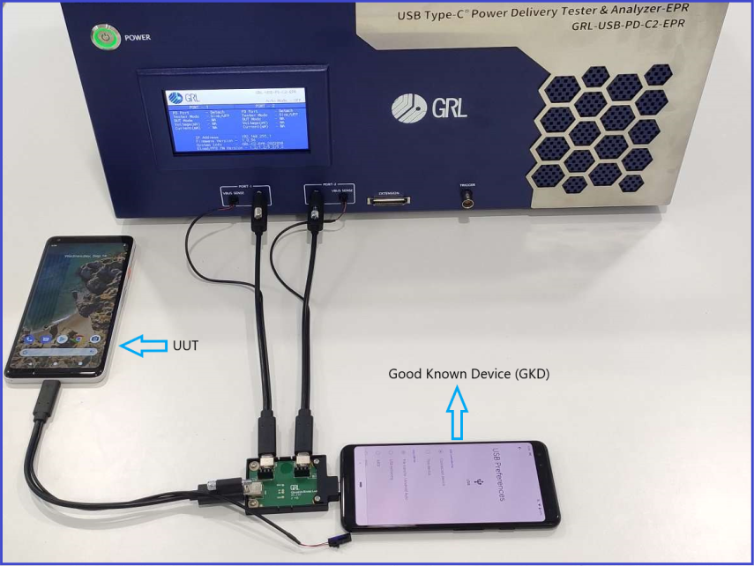
Fig: USB data validation TEST CONNECTION SETUP

5-USB Data validation Functional Test Procedure
This section describes how to perform USB Data validation Type-C Functional compliance testing based
on the latest revision of the ver0.87 specification. For detailed test information, please refer to the
specification document.
The following test methods are used to perform the USB Data validation Type-C Functional compliance
tests:
• USB Power Delivery (PD) validation without Data validation support.
• USB data validation with manual USB 2.0/3.1 validation.

5.1 USB PD Validation Without USB Data validation Support
The following procedure explains how to perform functional compliance testing only by using USB
PD negotiation without USB data validation support.
1. Connect the equipment for General Test setup
2. Open the GRL-USB_browser_App software and connect to the GRL-USB-PD-C2-EPR test controller,For
details on using the C2 / C2 EPR software please refer the website. (http://graniteriverlabs.com/download-center/).
3. Go to the “Product Capability” screen and load the VIF file of the UUT. User provide project name so when saving the file with required name would help user to identify the project currently worked and for later verification peruse [Note: A VIF file is required to ensure proper execution for all test cases, which otherwise most test runs may render incomplete without a VIF file.]
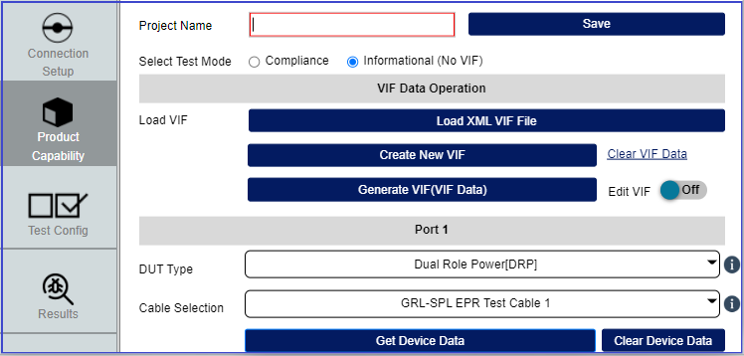
Fig: loading VIF file and selecting the ratio button as informational mode

4. After loading the VIF file, go to the “Test Configuration” screen and select the “USB-C
Functional Tests” check box button to access full functional tests.
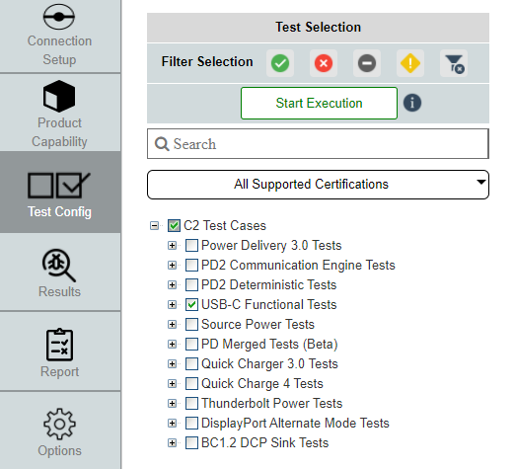
Fig: Functional MOI Selection

If select a particular test case, elaborate the + symbol to see the list of test case.
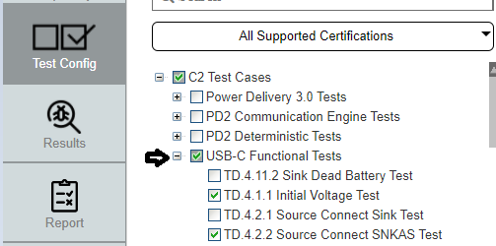
Fig: MOI test selection

After selecting the test cases, select the start execution icon to begin execution for the selected
test cases.
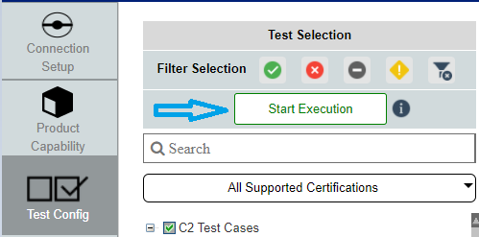
Fig: Start execution

NOTE: If User select Compliance mode based on VIF “Enable USB 2.0/3.1 data validation” checkbox will get updated. So, to select it as optional User need to select Informational mode.
So as without USB data validation case User can run test cases on Informational mode.
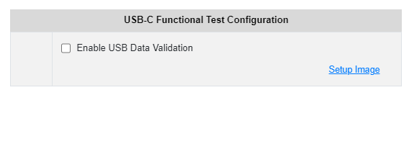

Fig: Disable USB data validation

5. The “Results” screen which should display all selected functional compliance tests. As tests are running, their progress and status of the test runs will be update if test case is elaborated. To view the live signal trace plot can be done in a parallel window which shows the signals. Also to check the plot is live or not you will get a notification of live symbol on right top corner as the image below.
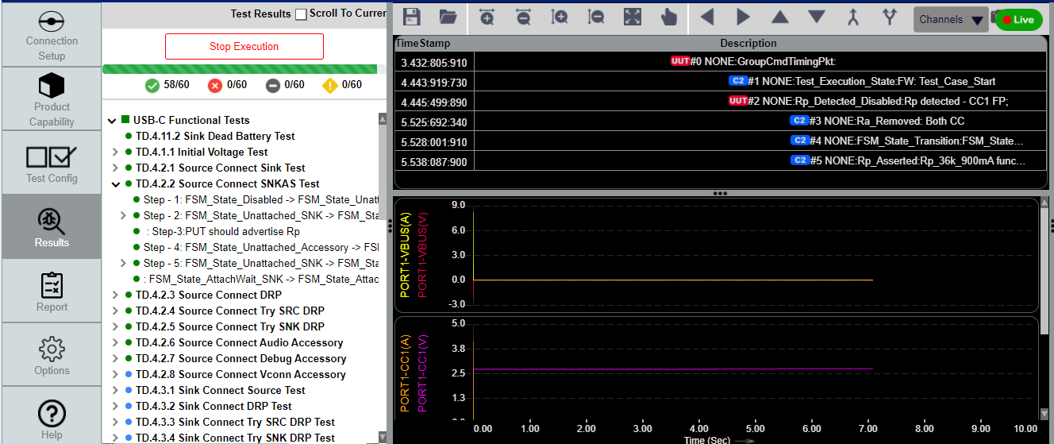
Fig: test case execution

- To stop the test run while in progress, select the “Stop Execution” button on the Results panel.
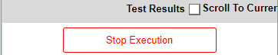
Fig: Stop execution in middle of run
In this panel also has option to move to the current running test case by click on the check box “Scroll to Current test Result” above stop execution.
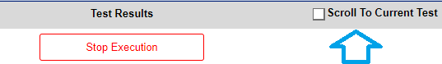
Fig: Jump to the running test case

7. After the test run has completed, go to the “Report” tab to download/ view the test results.

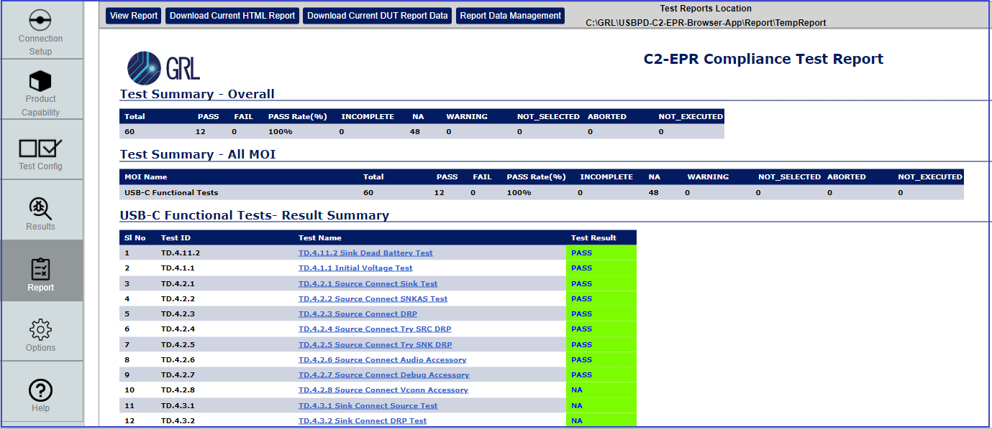
Fig: Report tab

View report - Refresh the tab with updated current run reports.
Download current HTML Report - Current run HTML alone can be downloaded, and HTML name also can be edited.
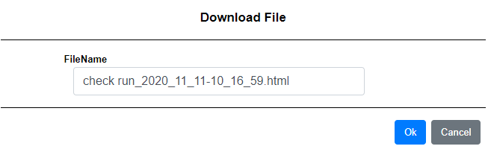
Fig: current HTML download option
Download current DUT Report data - full report with contain Signal wave-forms and summary and HTML can be downloaded as zip file, and also the file name can be edited.
Fig: current Report download option

Report Data Management - User can find all ran report even when they did not download the report on current run.
All the run will be stored on the Test report Location “C:\GRL\USBPD-C2-Browser-App\Report\TempReport”
This option helps us to download whenever it’s required and also help us to Delete the report.
Note: Once the report is deleted via Report data Management it will be deleted from TempReport location also which can’t be retrieved.

5.2 USB data validation:
The following procedure explains how to perform functional compliance testing with USB data validation enabled. if USB_Comms_Capable is set to “YES” in the VIF
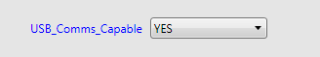
Fig: VIF field option

1. Connect the equipment for USB DATA VALIDATION TEST SETUP. (4.3. USB data validation setup)
2. Open the GRL-USB_browser_App software and connect to the GRL-USB-PD-C2-EPR test controller, For
details on using the C2 / C2 EPR software please refer the website. (http://graniteriverlabs.com/download-center/).
3. Go to the “Product Capability” screen and load the VIF file of the UUT. User provide project name so when saving the file with required name would help user to identify the project currently worked and for later verification perus [Note: A VIF file is required to ensure proper execution for all test cases, which otherwise most test runs may render incomplete without a VIF file.]

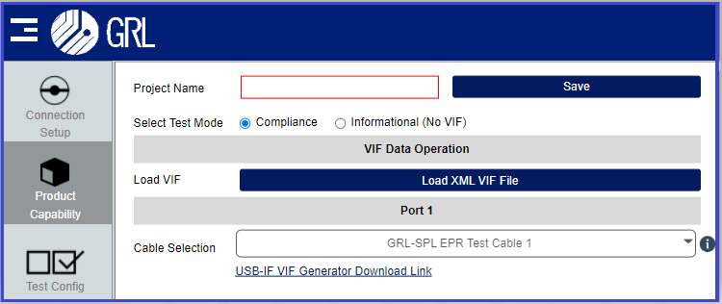
Fig: loading VIF file and selecting the ratio button as Compliance mode

4 . After loading the VIF file, go to the “Test Configuration” screen and select the “USB-C
Functional Tests” check box button to access full functional tests.
Fig: Functional MOI Selection

If select a particular test case, elaborate the + symbol to see the list of test case.
Fig: MOI test selection

After selecting the test cases, select the start execution icon to begin execution for the selected
test cases.
Fig:Start execution

the execution must be made in compliance mode only, So the USB data validation will get updated based on the VIF automatically. With following test methods USB data validation will be validated. When UUT able to support this USB Data validation will be executed. If not, the box will be disabled and User can’t able to change the option manual which will execute as normal run.
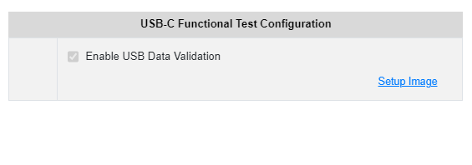
Fig: VIF support - enabled USB data
Fig: VIF not support - Disabled USB data

5.2.1. Test Methods
The test methods are described in the following sections to verify for USB Type-C High-
Speed Functional on CTS Functional MOI:
• Manual USB 2.0/3.1 data validation [manual enumeration check is required]

5.2.1.1 - Manual USB 2.0/3.1 data validation:

1. Once the test cases started to execute, the following screen will appear to check for Enumeration
status of the good-known device (GKD).
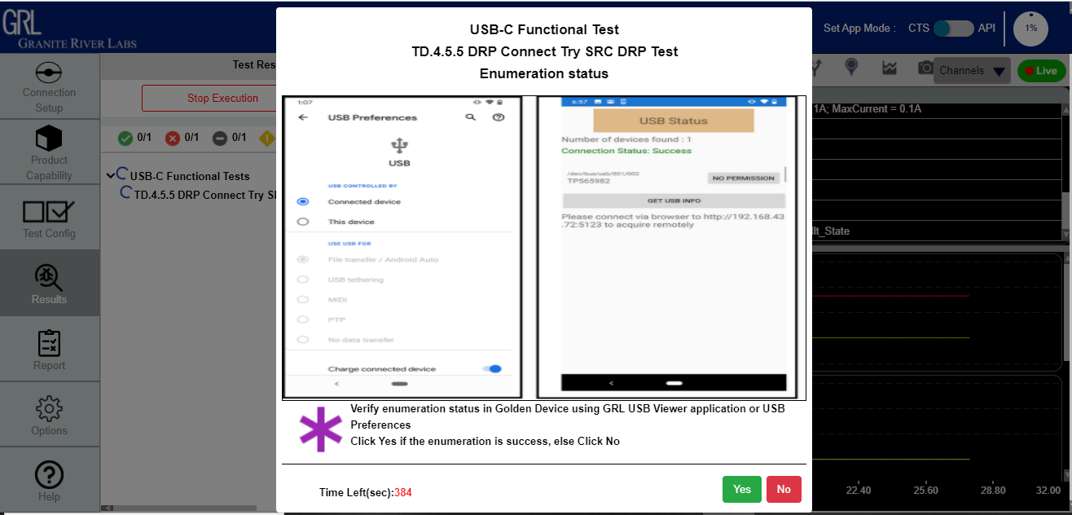
Fig: Enumeration check for successful pop-up

2. If the UUT is a Source device, the enumeration needs to be validated in the UUT’s Device
Manager, and if the UUT is a Sink device the enumeration needs to be validated in the GKD. If so, click “Yes” to proceed or otherwise click “No”.
3. If the GKD is enumerating correctly, the next following screen will appear to verify if the enumeration has been ceased. If so, click “Yes” to proceed or otherwise click “No” if User able to see enumeration still.
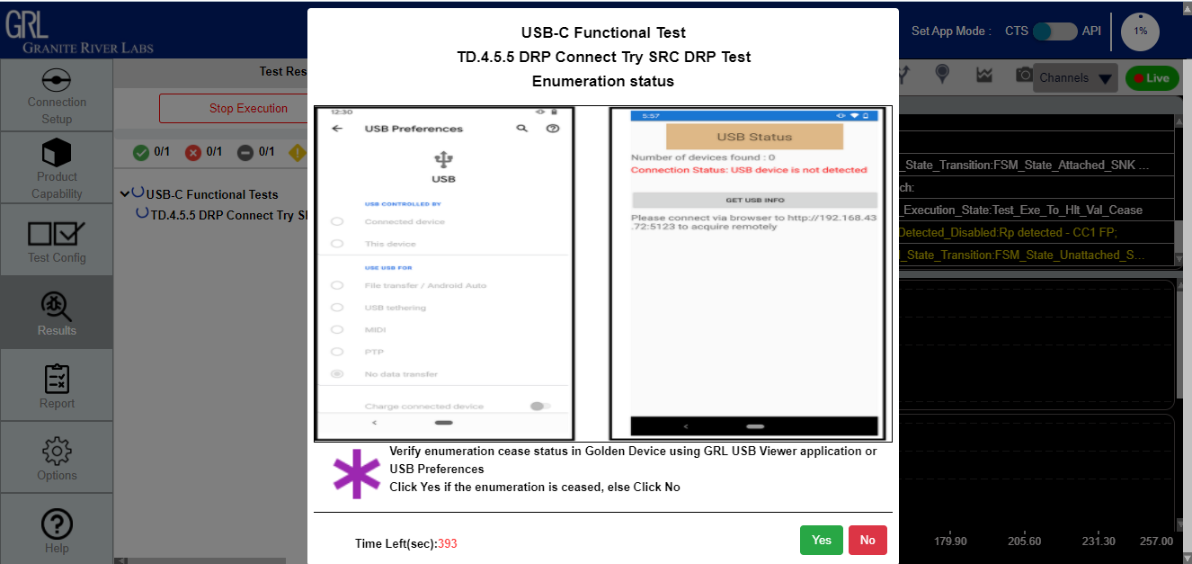
Fig: Enumeration ceased pop-up

6-Test case pop-ups:

When running functional compliance tests, certain test cases will require user input to proceed
further. User input will be prompted through pop-up messages for the following test cases:

a. Test Case TD.4.1.1 Initial Voltage Test ‒ if the “Enable USB data validation” check box is selected, the pop-up message for this test case requires the user to connect the UUT directly to Port 1 of the GRL-USB-PD-C2-EPR test controller without any fixture or extension board attached. After the test case has been executed, another pop-up message will appear, which ask User to connect to older FCB setup.
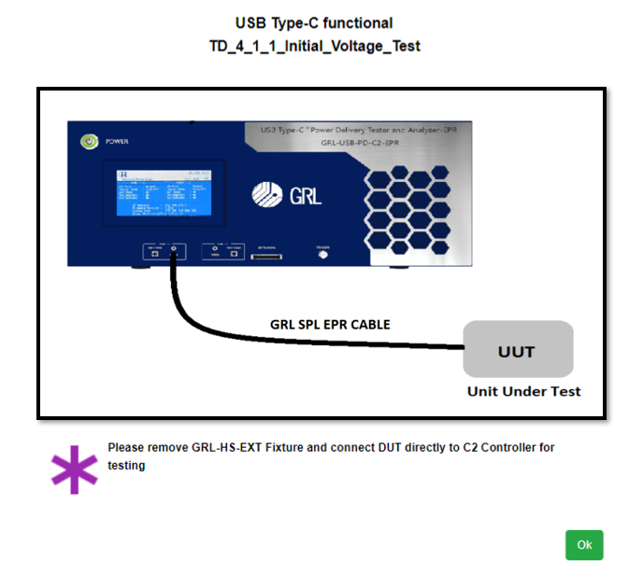

b. Test Case TD.4.1.2 Unpowered CC Voltage Test ‒ While test is running, the user will be
required to remove the UUT power After the test run has completed, the user will then need to re-connect power supply to the UUT.

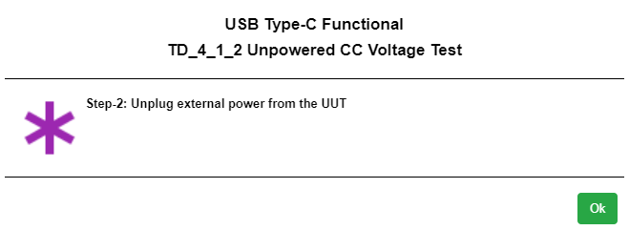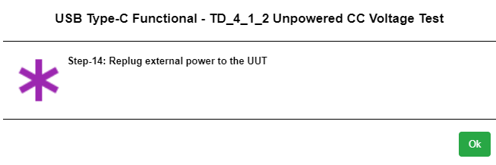

c. Test Case TD.4.9.1 Source Suspend Test ‒ After successful enumeration in compliance to
CTS requirements, the user will be required to suspend the UUT high-speed link (The Operator suspends the link using whatever method is available). When done, select “Yes” to proceed or “No” if otherwise. After the test run has completed, the user will then be required to resume the UUT high-speed link, again select “Yes” when done or otherwise select “No”.

d. Test Case TD.4.11.2 Sink Dead Battery Test ‒ This test case checks if the battery of the
UUT is dead or 0% charged. The user will first need to check whether or not a battery is
connected to the UUT at test config Tab. Enable the check box if a battery is attached.
If a battery is attached, A pop-up message will ask to verify the UUT Dead battery is connected. Select “YES” to proceed with the verification test otherwise update with “No” input. Once a dead
battery has been verified, the user will then be required to remove the dead battery and replace
with a charged battery for testing to continue.

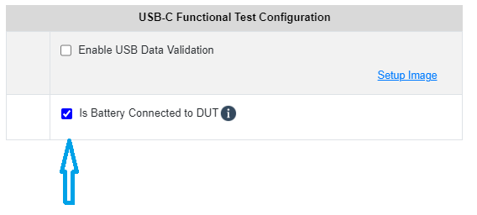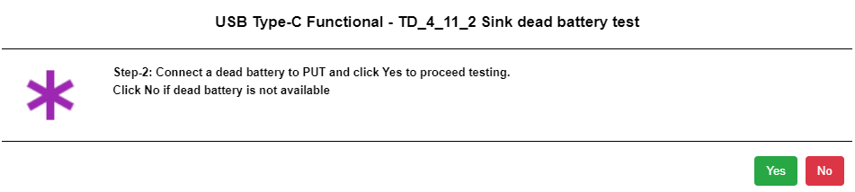

Fig. Battery check Fig. Dead battery connection pop-up

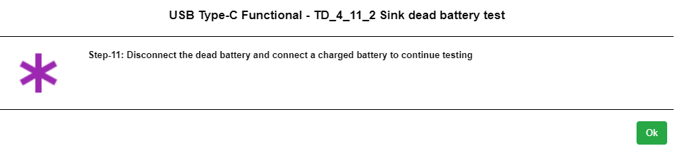
Fig. User need to connect the charged battery again.

E. Test Case TD.4.12.2 Hub Port Type Test ‒ This test case is only applicable when the UUT
Type_C_Port_On_Hub is set to “YES” in the VIF. The user will first need to check hub port is embedded or not which will be done in “Test Configuration”. User need to provide input regarding the number of USB type-C ports & Number of USB Type-B/Micro-B receptacle or Type-A plug. when UFP = 0 at test config Tab.
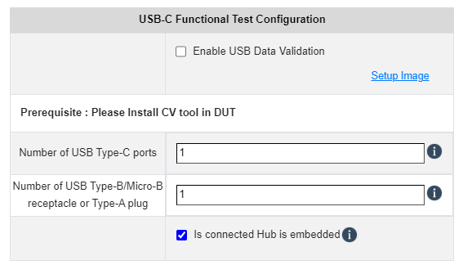
- CV tool usage:
7.1 Test case 4.9.1 CV tool steps
7.2 Test case 4.10.1 CV tool steps
7.3 Test case 4.10.2 CV tool steps
7.4 Test case 4.10.3 CV tool steps

Follow the steps below on using the CV Tool:
- Open the USB 3 Gen x CV and the “Command Verifier” pop-up message will appear Select the required host controller from the list to load the test stack switch and then select “Continue”. Wait until the stack switch is loaded. Where necessary the user may also need to reboot the GKD if prompted.
- If rebooting the GKD, open the USB 3 Gen x CV again after reboot and repeat step i.
- When the “USB 3 Gen X Command Verifier” window appears,

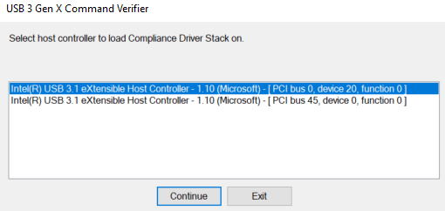
Fig Host controller selection

Iv. The following steps will be based on selected test case:

7.1. Test case 4.9.1 CV tool steps.
perform the following steps for 4.9.1 test case:
a. In the Select Test Suite field, select “Current Measurement Tests [USB 3 devices]”.
b. In the Select Test Mode field, select the “Debug” radio button.

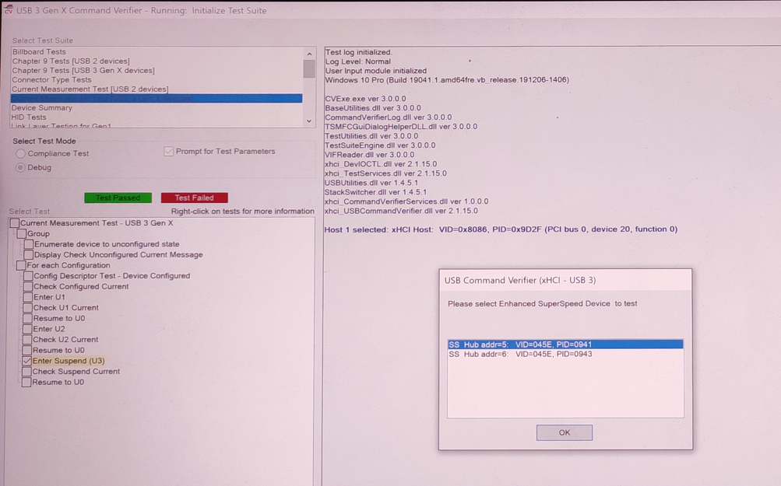

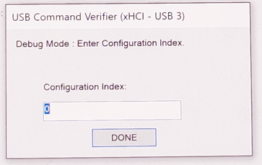

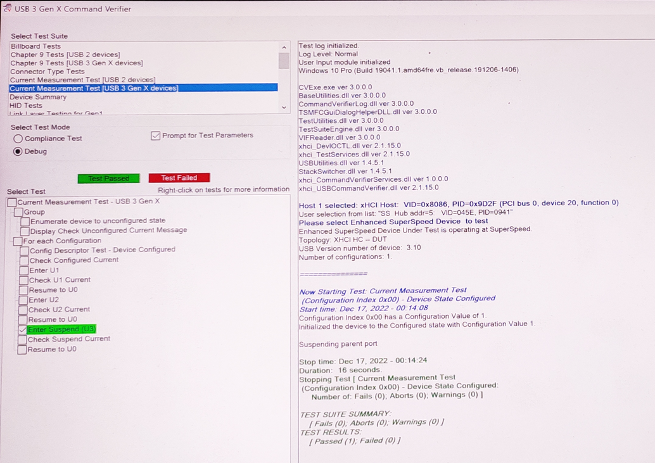

c. In the Select Test Suite field, select “Current Measurement Tests [USB 2 devices]”.
d. In the Select Test Mode field, select the “Debug” radio button.
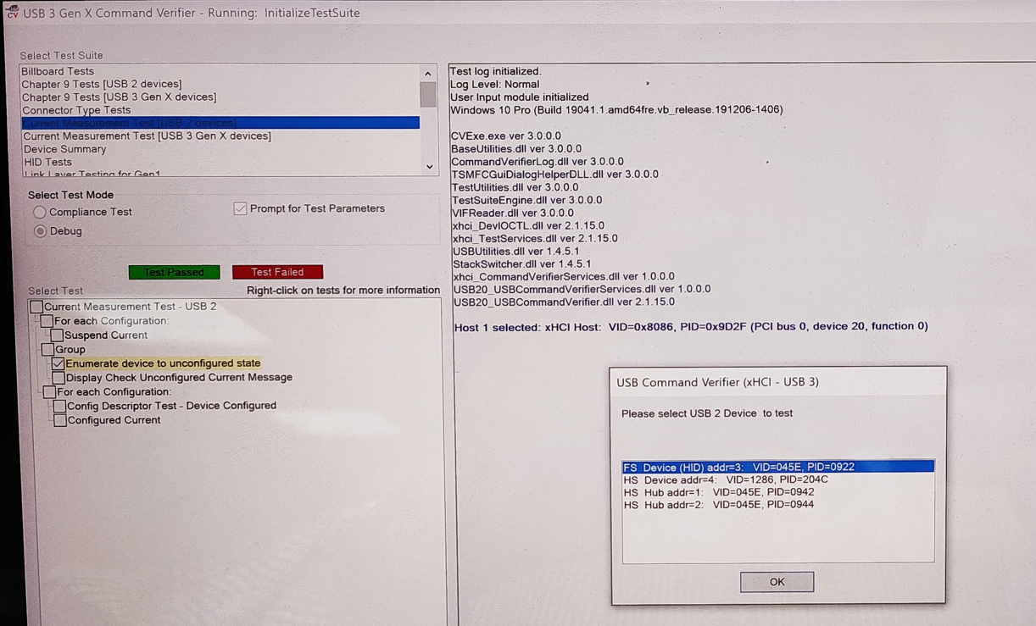

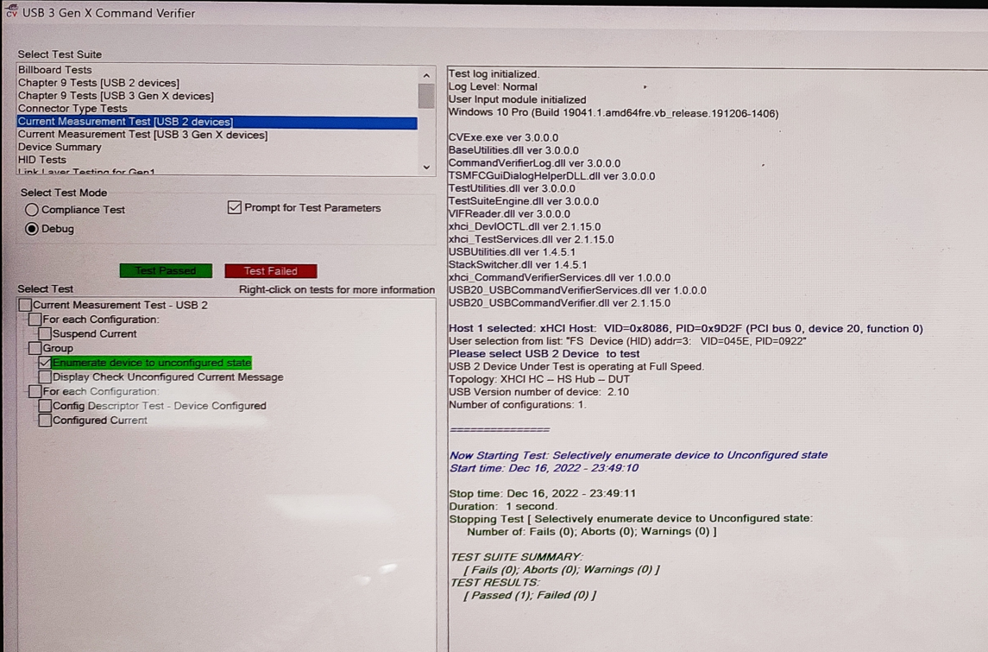

7.2 Test case 4.10.1 CV tool steps:
perform the following steps for 4.10.1 test case:
a. In the Select Test Suite field, select “Chapter 9 Tests [USB 2 devices]”.
b. In the Select Test Mode field, select the “Debug” radio button.
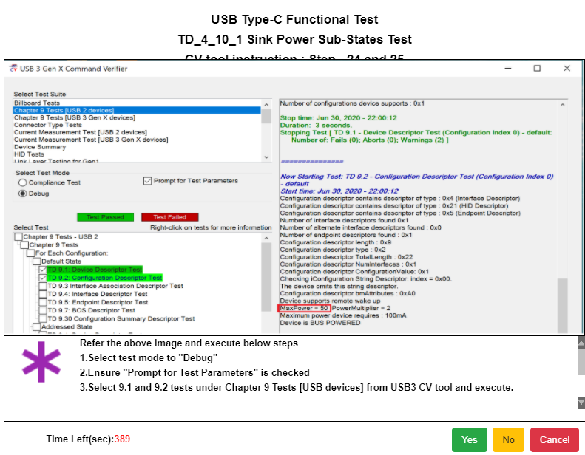
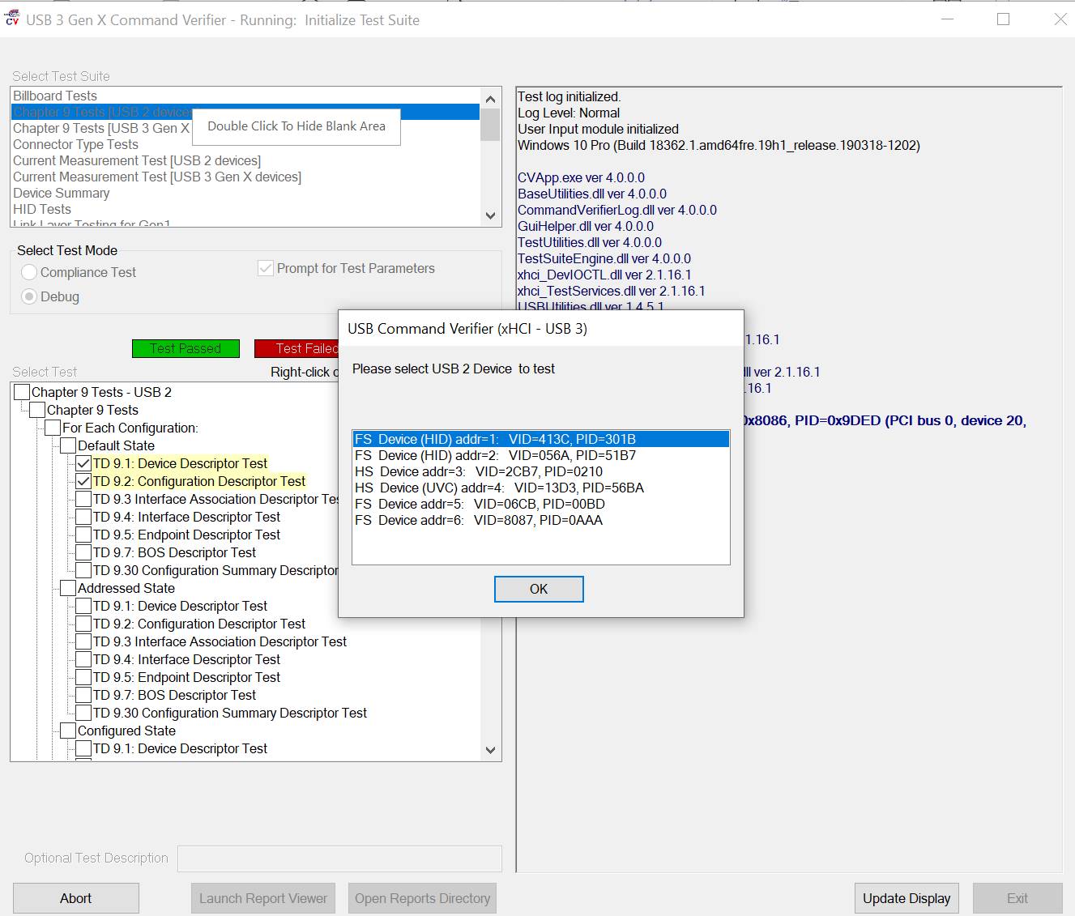
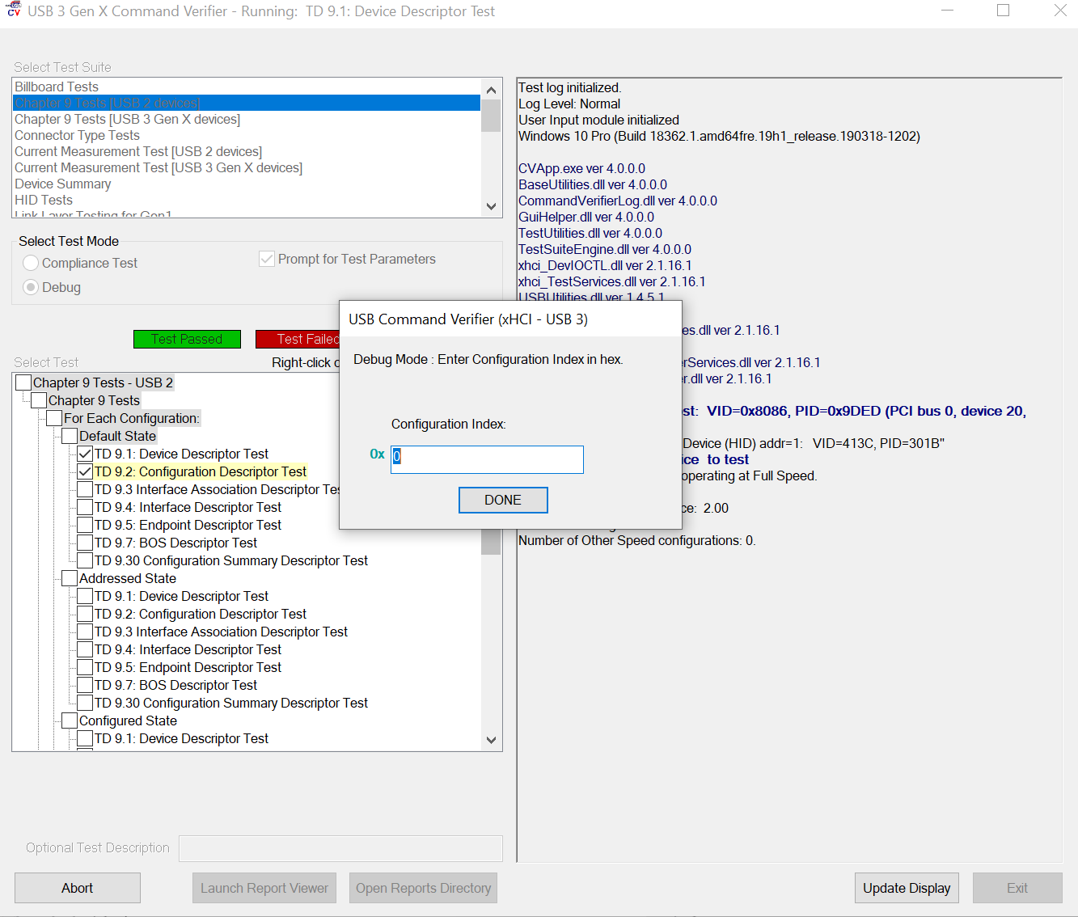

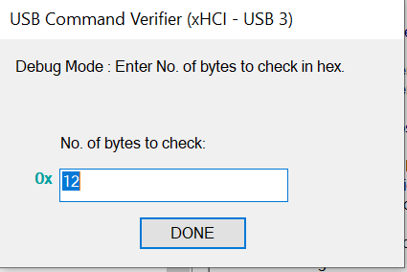
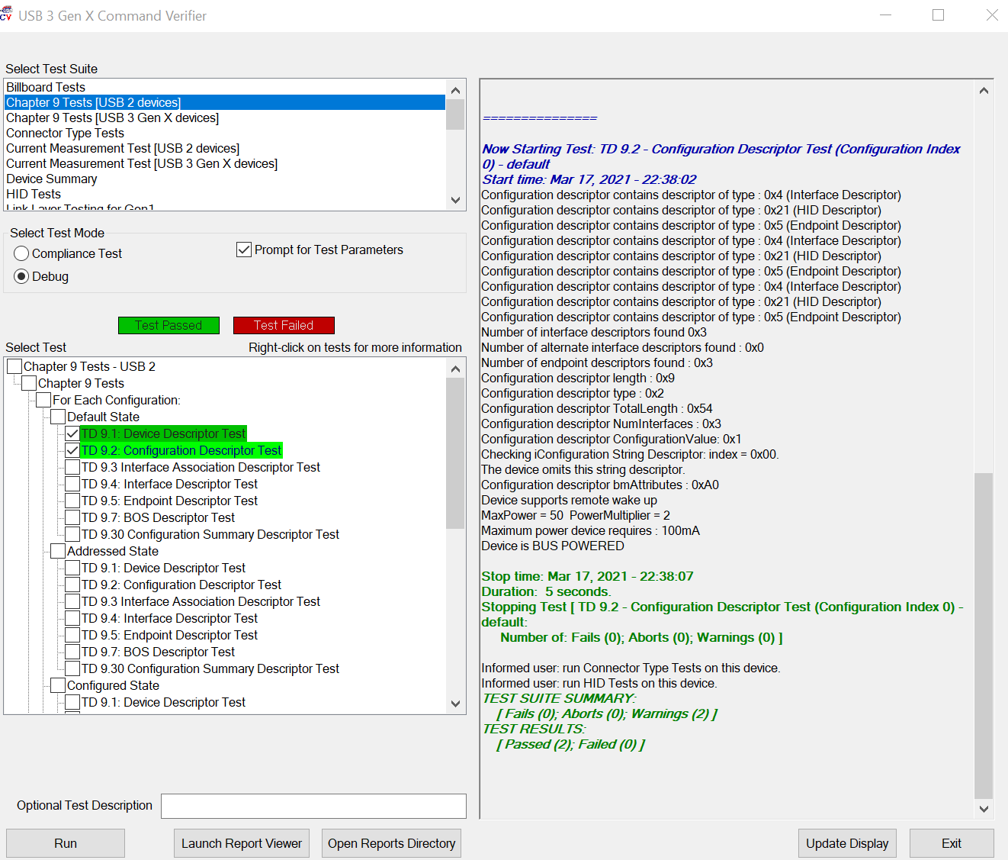
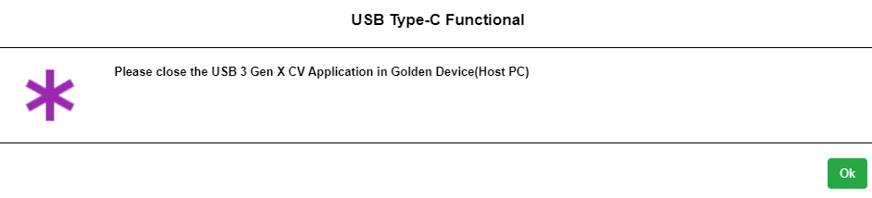

7.3 Test case 4.10.2 CV tool Steps:
. perform the following steps for 4.10.2 test case:
a. In the Select Test Suite field, select “Chapter 9 Tests [USB 2 devices]”.
b. In the Select Test Mode field, select the “Debug” radio button.
c. In the Select Test field, select the “TD 9.16: Enumeration Test” checkbox.
d. Finally, select the bottom “Run” button to execute the Enumeration test.
E. While test is running, the “USB Command Verifier (xHCI- USB 3)” pop-up message will display a list of FS devices. Select the FS Device as supported by the UUT and select “OK”.
F. In the next pop-up message (Figure 5.36 below), the user will need to enter the required enumeration loop count for Debug mode and select “DONE” And update the status on the browser_app pop-up.
[Note: 10 is the preferred count].
G. When the “USB 3 Gen X Command Verifier” window appears perform the following steps:
H. In the Select Test Suite field, select “Chapter 9 Tests [USB 2 devices]”.
I. In the Select Test Mode field, select the “Debug” radio button.
j. In the Select Test field, select the “TD 9.13: Set Configuration Test” checkbox.
k. Finally, select the bottom “Run” button to execute the Set Configuration test.
L. While test is running, the “USB Command Verifier (xHCI- USB 3)” pop-up message will display a list of FS Devices (Figure 5.40 below). Select the FS Device as supported by the UUT and select “OK”.
M. In the next pop-up message (Figure 5.41 below), the user will need to enter the appropriate Configuration Index value in hex for Debug mode and then select “DONE”.
N. And update the status on the browser_app pop-up.
O. If the test Fails or the user selects “Cancel” in the pop-up message, the user will be required to perform CTS “TD 7.40 Warm Reset” test as prompted by the following pop-up message on the GRL-USB-PDC2 test controller.
P. And update the status on the browser_app pop-up.
Q. When the “USB 3 Gen X Command Verifier” window appears (Figure 5.44 below),
perform the following steps:
r. In the Select Test Suite field, select “Link Layer Testing for Gen2”.
s. In the Select Test Mode field, select the “Debug” radio button.
t. In the Select Test field, select the “TD 7.40 Warm Reset” checkbox.
u. Finally, select the bottom “Run” button to execute the Warm Reset test.
V. While test is running, the user will be asked to confirm warm reset to be carried out on
the UUT Select “OK” to proceed. And update the status on the browser_app pop-up.

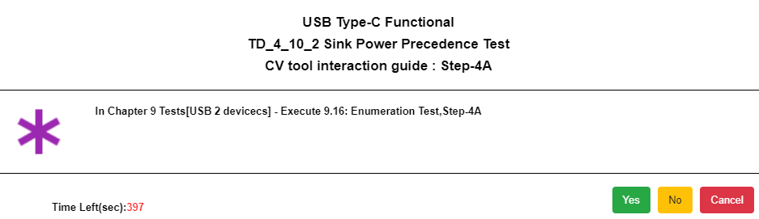
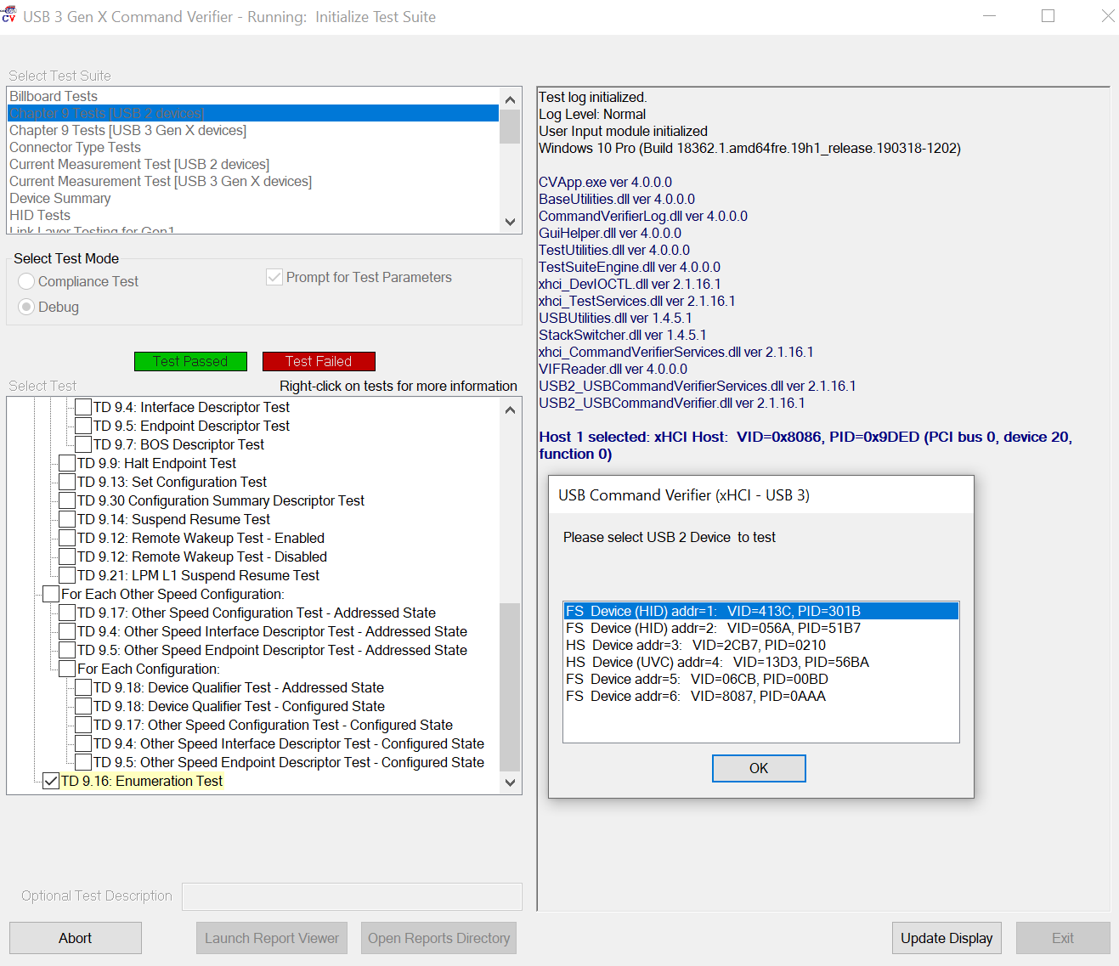
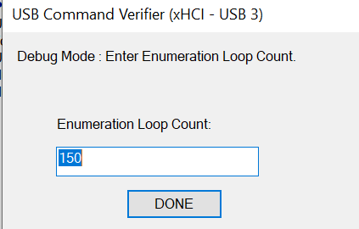
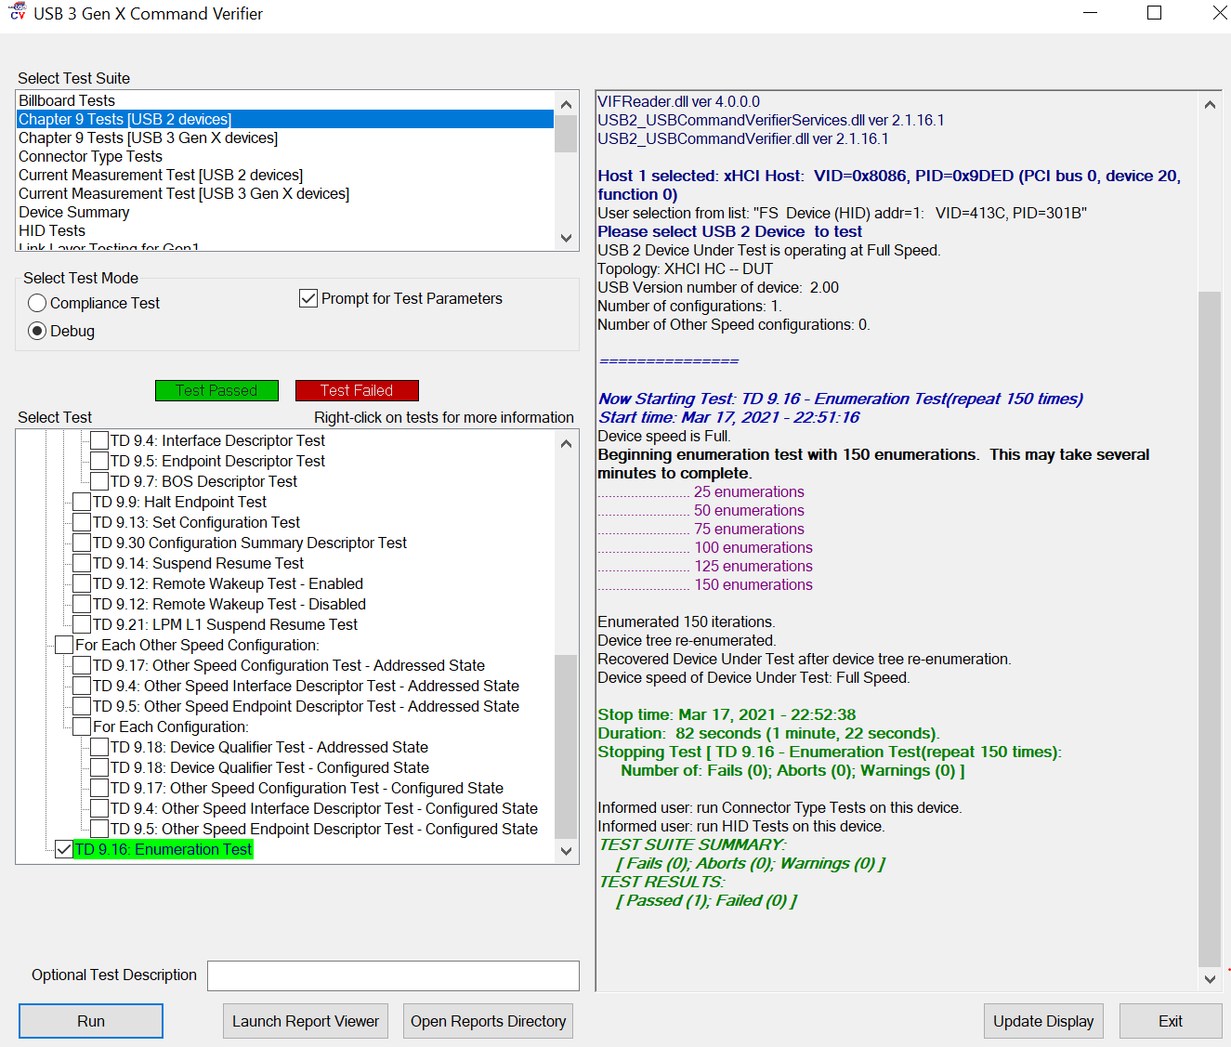

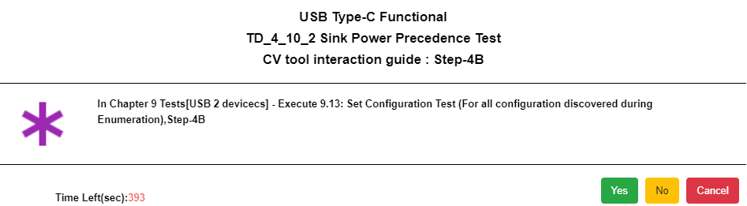
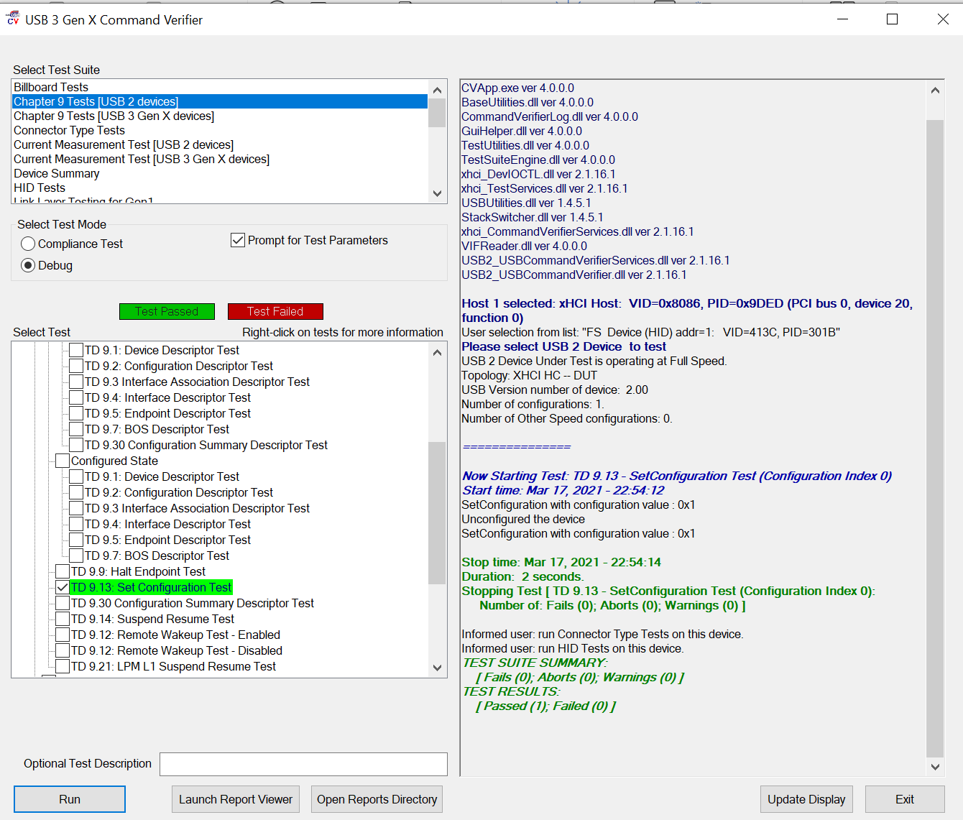
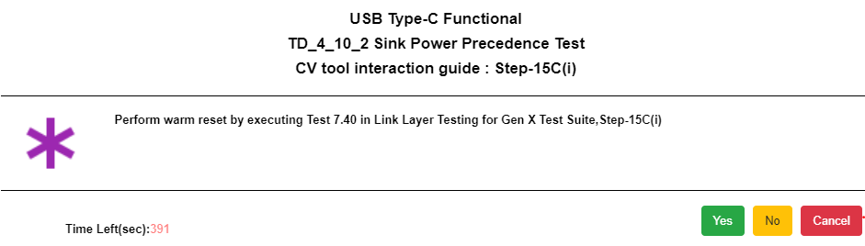
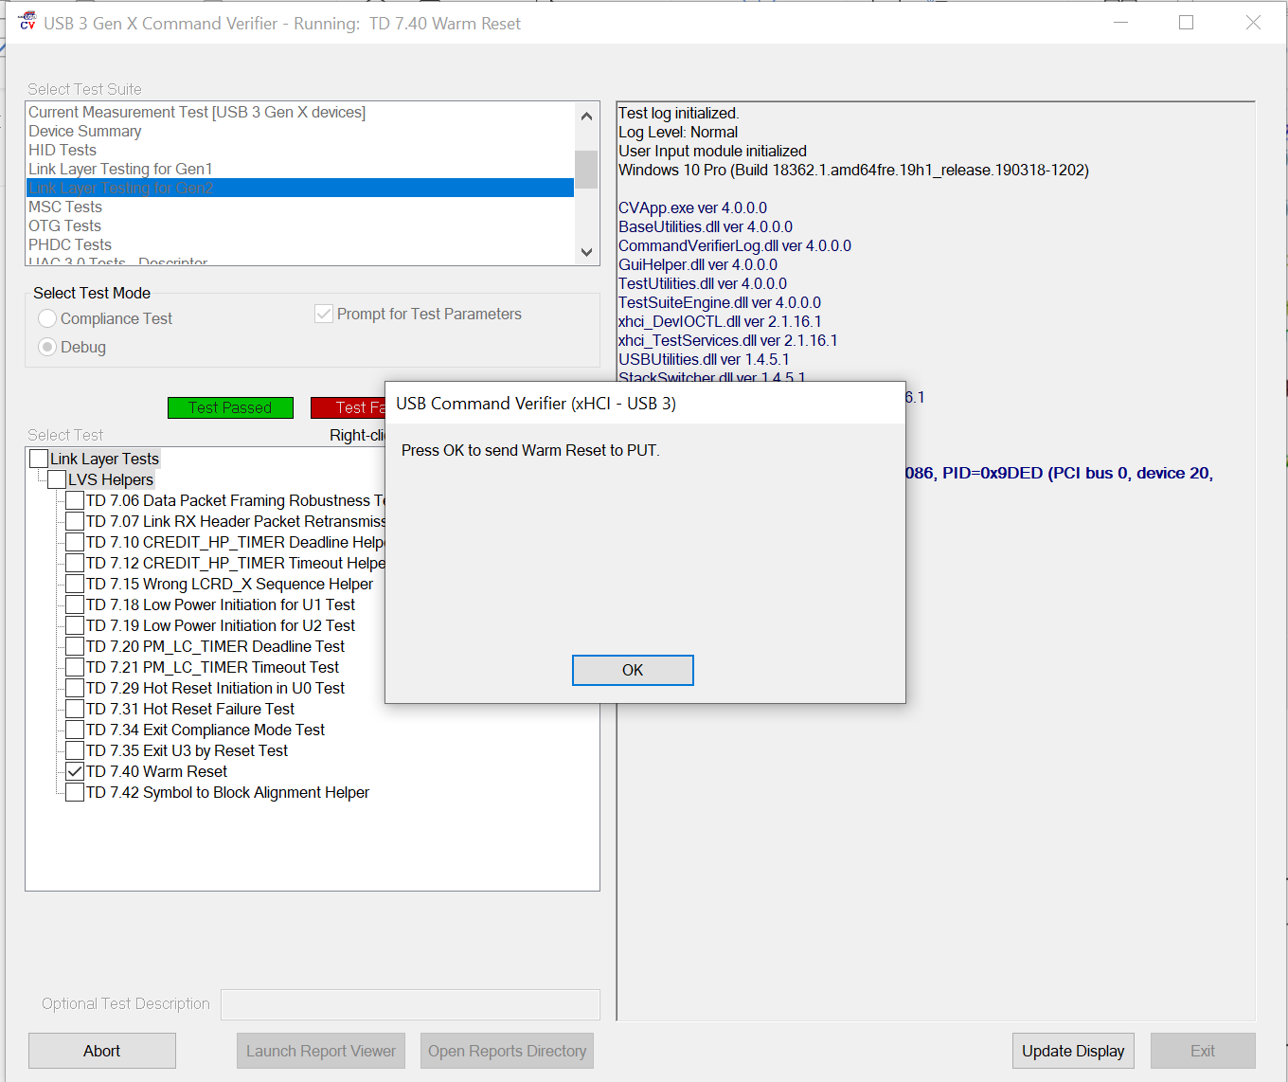
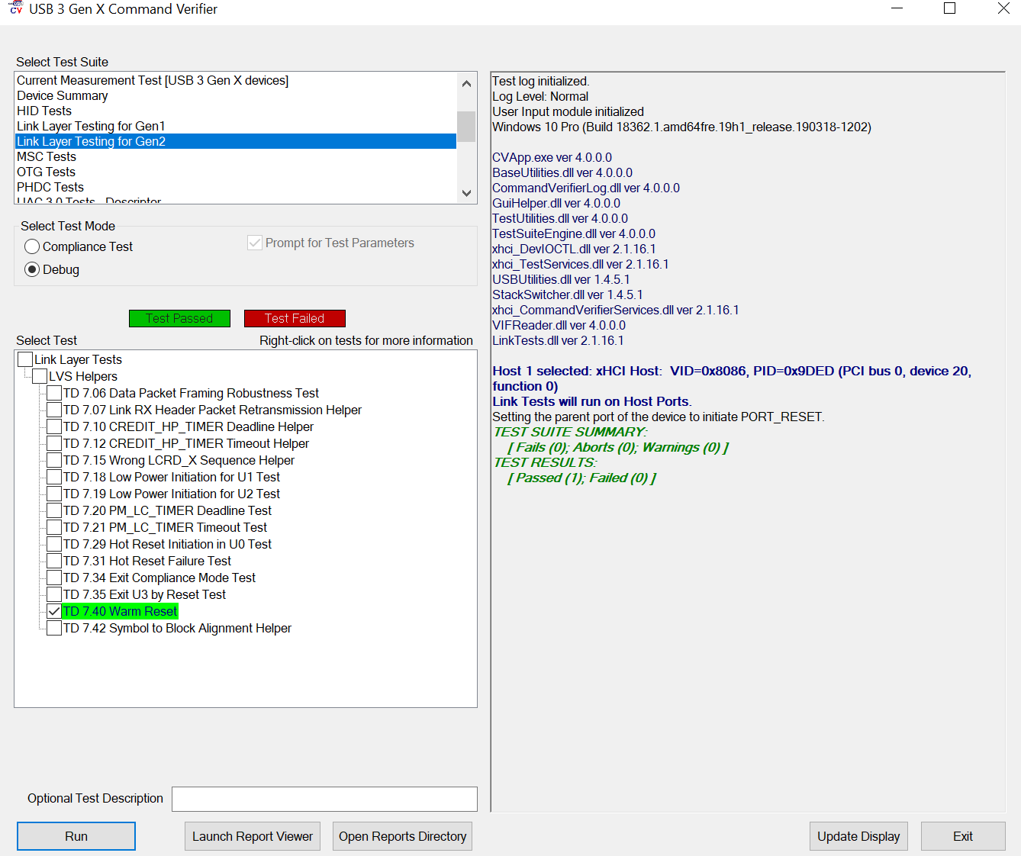
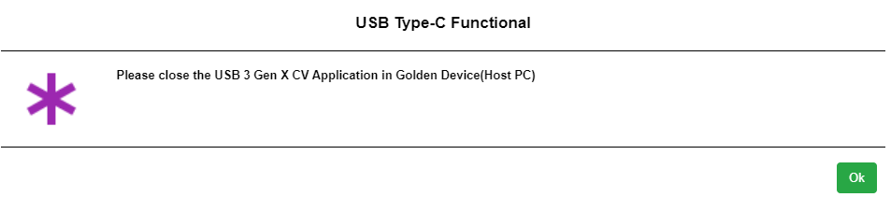

7.3 Test case 4.10.3 CV tool Steps:
In the following 4.10.3 test case we have to category based on USB of the Device.
7.3.1 USB 3 device.
7.3.2 USB 2.0 Device.

perform the following steps for 4.10.3 test case:
a. In the Select Test Suite field, select “Current Measurement Test [USB 3 Gen
X devices]”.
b. In the Select Test Mode field, select the “Debug” radio button.
c. In the Select Test field, select the “Enter Suspend (U3)” checkbox.
d. Finally, select the bottom “Run” button to execute the Suspend UUT Link test.

Perform the Following steps for 4.10.3 test case:
- In the select Test Suite field
