**Granite River Labs**

**Addendum**

For Hardware Setup and USB Type-C High-Speed Functional Test

Methods with GRL-USB-PD-FCB Type-C Functional Compliance

Board and GRL USB Type-C® Power Delivery Tester and

Analyzer (GRL-USB-PD-C2)

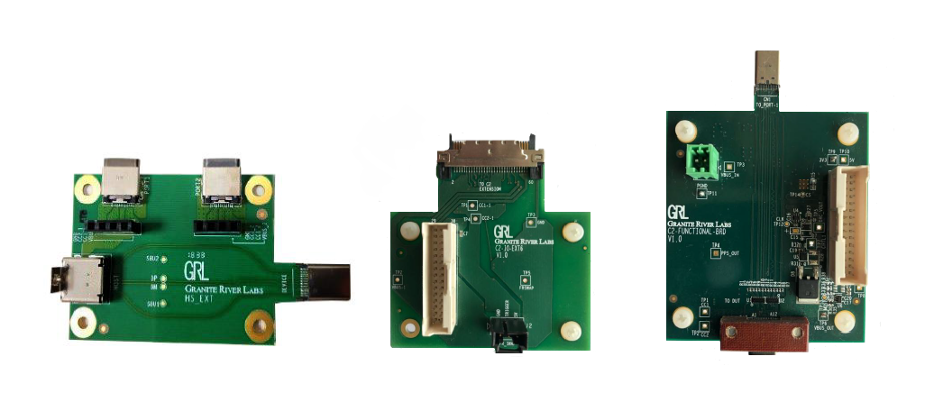

This material is provided as a reference to set up the hardware and perform USB Type-C High-Speed

Functional compliance testing using the Granite River Labs Type-C Functional Compliance Board

(GRL-USB-PD-FCB) and GRL-USB-PD-C2 test controller as main equipment.

For software support, contact support@graniteriverlabs.com.

Documented based on USB Type_C Specification - Release 2.0

&

Documented based on USB Type_C Functional -Release 0.88

Table of contents

**1-SCOPE OF THIS ADDENDUM**

**2-TEST MODES**

2.1 Compliance mode.

2.2 Informational mode.

**3-TEST/EQUIPMENT REQUIREMENTS**

**4-USB TYPE-C HIGH-SPEED FUNCTIONAL TEST SETUP**

4.1 GENERAL TEST SETUP

4.1.1 For the non-captive cable UUT

4.1.2 For the captive-cable UUT

4.2 REGRESSION TEST SETUP

4.3 USB DATA VALIDATION TEST SETUP

4.4 USB DATA VALIDATION & REGRESSION TEST SETUP

**5-USB DATA VALIDATION FUNCTIONAL TEST PROCEDURE**

5.1 USB Power Delivery (PD) validation without Data validation support.

5.2 USB data validation.

5.2.1 Test Methods

5.2.1.1 Manual USB 2.0/3.1 Data Validation

**6-TEST Case pop-ups.**

**7-CV tool use.**

7.1 Test case 4.10.1 CV tool steps.

7.2 Test case 4.10.2 CV tool steps

7.3 Test case 4.10.3 CV tool steps.

7.3.1 USB 3.1 Device.

7.3.2 USB 2.0 Device.

**1-Scope of this Addendum**

This Addendum serves as the supplementary documentation to connect the GRL-USB-PD-FCB

Type-C Functional Compliance Board to the GRL-USB-PD-C2 USB Type-C Test Controller and

unit-under-test (UUT) for USB Type-C High-Speed Functional compliance testing. This will be

followed by Methods of Implementation (MOI) procedures to perform manual 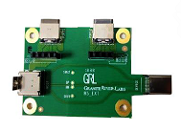testing using the GRL-C2_Browser_App software and test setups.

Below describes the GRL-USB-PD-FCB Type-C Functional Compliance Board, which comprises the

following test fixture, boards and cable:

• **GRL-HS-EXT Fixture** – Extension fixture for GRL-USB-PD-C2

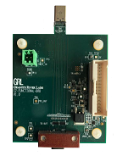test controller, used to control VBUS and CC lines between

connected devices without interfering the high-speed lines between

Type-C input/output connectors.

• **GRL-C2-Functional-BRD** – Functional board for GRL-USB-PDC2

test controller, used to support the latest CTS functional

requirements.

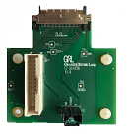

• **GRL-C2-IO-EXT6** – Extension board for GRL-USB-PD-C2 test

controller, used to provide signal triggering for GRL-C2-

Functional-BRD functional board.

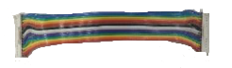• **EXT6-IO-Cable** – Input/output test cable, used for connecting

GRL-C2-IO-EXT6 extension board with GRL-C2-Functional-BRD

functional board.

**2-TEST MODES:**

Open the GRL-C2 browser application and once the connection is established in Connection tab, go to tye Product Capability tab. In the Product Capability tab, enter the project name. Once the project name is entered, select one of the following modes:  
 2.1 Compliance mode

2.2 Informational mode

*(For more details on each mode, refer to Section 5.1 Product Capability in the GRL-C2 browser app user documentation which can be downloaded at* https://graniteriverlabs.com/download-center/*.)*

**2.1 Compliance Mode:**

The Compliance Mode is used for Certification run. In this mode, the user can load the VIF and select the cable type before proceeding to the Test Config tab.

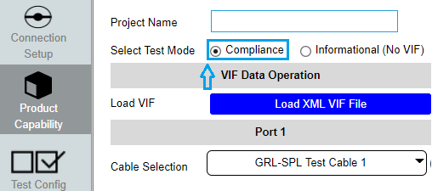

Fig: Compliance Mode test option

In the Test Config tab, select the USB-C Functional Test MOI. Set up the configuration for selected Test cases. By default some fields such as USB data validation will be updated with the information from the loaded VIF. The user has the option:

- To enable the DUT embedded Hub and DUT battery connected as per CTS

- To enter the number of USB Type-C ports on the DUT.

- To enter the number of USB Micro-B/Type-B or Type-A ports on the DUT.

Make sure to verify the **Setup Image** before test execution for proper hardware connection.

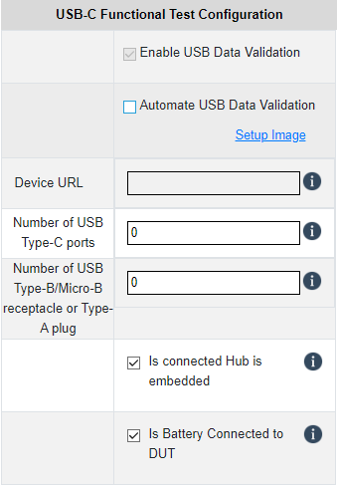

Fig: Test Configuration - Compliance mode

**2.2 Informational Mode:**

The Informational Mode is used for information purposes only. In this mode the user can create a new VIF file with Device data, run test cases without loading a VIF file, generate a VIF file using the VIF Generator and change test configuration as required for both Ports 1 and 2. *(Note: USB data validation can be enabled/disabled manually).*

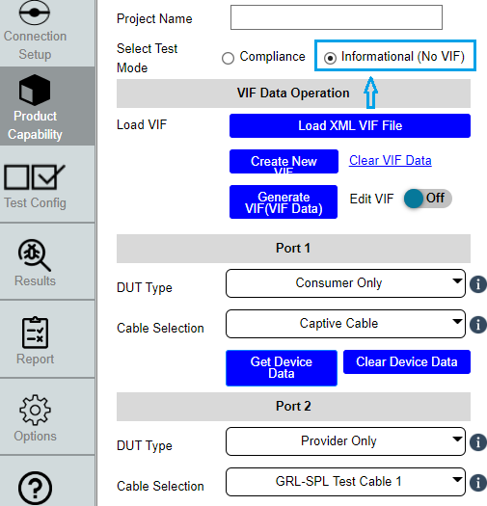

Fig: Informational mode

In the Test Config tab, select the USB-C Functional Test MOI. Set up the configuration for selected Test cases. The user has the option:

- To enable the DUT embedded Hub and DUT battery connected as per CTS

- To enable/disable USB data validation

- To enter the number of USB Type-C ports on the DUT.

- To enter the number of USB Micro-B/Type-B or Type-A ports on the DUT.

Make sure to verify the **Setup Image** before test execution for proper hardware connection.

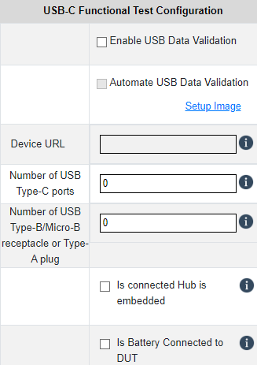

Fig: Test Configuration - Informational mode

**3-Test/Equipment Requirements:**

*For purchase or information of the following items, contact info@graniteriverlabs.com.*

• GRL-USB-PD-FCB Type-C Functional Compliance Board package (GRL-HS-EXT test fixture,

GRL-C2-Functional-BRD functional board, GRL-C2-IO-EXT6 extension board and EXT6-IOCable

test cable)

• GRL-USB-PD-C2 USB Type-C test controller

• 2 x GRL Special (GRL-SPL) Type-C VCONN passthrough test cables (GRL-USB-PD-STC)

*[Note: GRL recommends using 3 x GRL-SPL cables for the non-captive cable UUT setup.]*

• Good-known device (GKD) with USB Type-C Power Delivery Data port (computer or phone,

USB-IF compliant) *[Note: GRL recommends using the Google Pixel 3 phone as GKD.]*

• CV tool software (*USB Gen3*) in the HOST laptop is recommended for better execution. The CV tool software can be downloaded from the USB-IF website.

**4-USB Type-C High-Speed Functional Test Setup**

This section describes the hardware connections and procedures to set up the equipment and fixture for

USB Type-C High-Speed Functional compliance testing. Below are the different types of test setups:

• General test setup ‒ *Applicable for all type of FUT’s.*

• Regression test setup ‒ *Applicable only for specific test cases.*

• High-Speed Validation test setup ‒ *Applicable only when USB data validation is enabled.*

Make sure to follow all the steps as described below before proceeding with test execution.

*For details on using the GRL-C2 Browser App, refer to the user documentation in*

[https://graniteriverlabs.com/download-center/*.*](https://graniteriverlabs.com/download-center/.)

**4.1 General Test Setup**

**4.1.1 For the non-captive cable UUT:**

Connect the UUT directly to Port 1 of the GRL-USB-PD-C2 test controller using the GRL-SPL cable,

as shown in figure below.

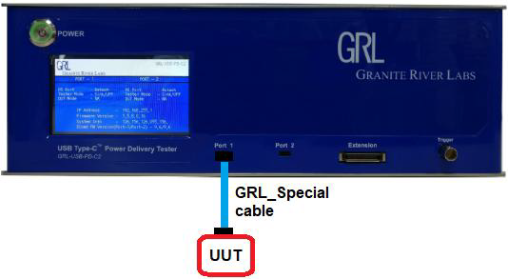

Fig: GENERAL TEST CONNECTION SETUP ‒ FOR NON-CAPTIVE UUT

**4.1.2 For the captive-cable UUT:**

Connect the UUT directly to Port 1 of the GRL-USB-PD-C2 test controller using a captive cable, as

shown in figure below.



Fig: GENERAL TEST CONNECTION SETUP ‒ FOR CAPTIVE-CABLE UUT

**4.2 Regression Test Setup**

Figure below shows the connection setup diagram for the following steps.

1. Connect the plug side (with the “*CN1_TO_port1*” marker) of the GRL-C2-Functional-BRD to

Port 1 of the GRL-USB-PD-C2 test controller. Connect the UUT (with the “DUT” marker) to

the Receptacle port of the GRL-C2-Functional-BRD.

2. Connect the GRL-C2-IO-EXT6 to the Extension port of the GRL-USB-PD-C2 test controller.

3. Connect both the GRL-C2-Functional-BRD and GRL-C2-IO-EXT6 with the EXT6-IO-Cable.

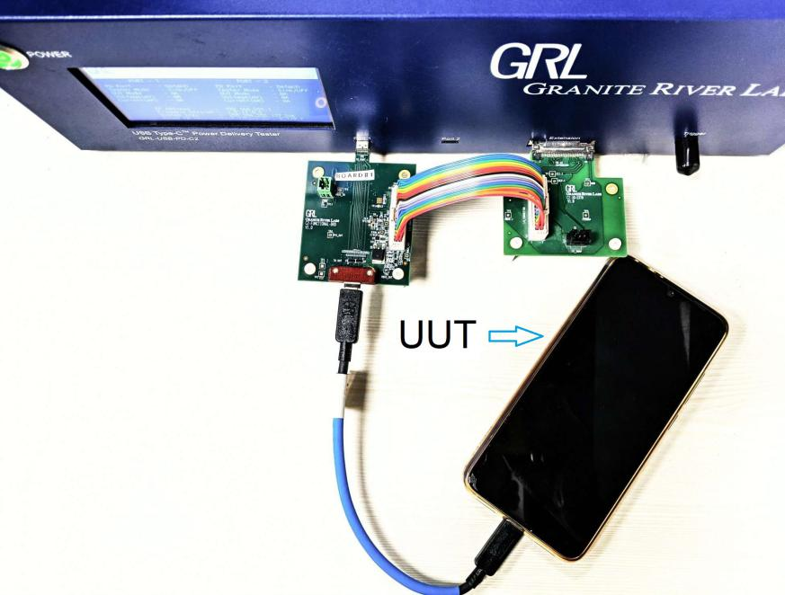

Fig: REGRESSION TEST CONNECTION SETUP

**4.3 USB Data Validation Test Setup**

Figure below shows the connection setup diagram for the following steps.

1. Connect Port1 and Port2 of the GRL-HS-EXT fixture to Port 1 and Port 2 of the GRL-USB-PD-

C2 test controller respectively using the GRL-SPL cable.

2. Connect the good-known device (GKD) to the plug side of the GRL-HS-EXT fixture.

3. Connect the UUT (if non-captive cabled) to the Receptacle port of the GRL-HS-EXT fixture

using the GRL-SPL cable. (If captive-cabled, connect it directly to the Receptacle port)

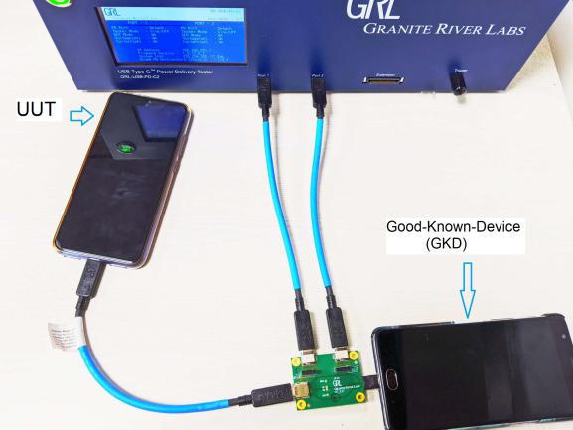

Fig: USB data validation TEST CONNECTION SETUP

**4.4 USB Data Validation & Regression Test Setup**

Figure below shows the connection setup diagram for the following steps.

1. Connect the plug side (with the “*CN1_TO_port1*” marker) of the GRL-C2-Functional-BRD to

Port 1 of the GRL-USB-PD-C2 test controller. Connect Port1 of the GRL-HS-EXT fixture to

the Receptacle port of the GRL-C2-Functional-BRD.

2. Connect the GRL-C2-IO-EXT6 to the Extension port of the GRL-USB-PD-C2 test controller.

3. Connect both the GRL-C2-Functional-BRD and GRL-C2-IO-EXT6 with the EXT6-IO-Cable.

4. Connect Port2 of the GRL-HS-EXT fixture to Port 2 of the GRL-USBPD-

C2 test controller respectively using the GRL-SPL cable.

5. Connect the good-known device (GKD) to the plug side of the GRL-HS-EXT fixture.

6. Connect the UUT (if non-captive cabled) to the Receptacle port of the GRL-HS-EXT fixture

using the GRL-SPL cable. (If captive-cabled, connect it directly to the Receptacle port).

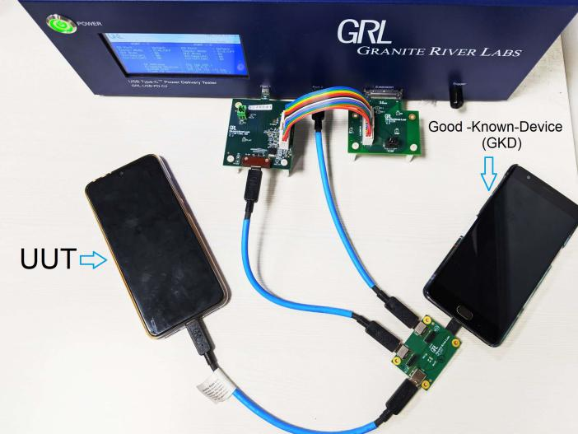

Fig: USB data validation & Regression TEST CONNECTION SETUP

**5-USB Data Validation Functional Test Procedure**

This section describes how to perform USB Data Validation Type-C Functional compliance testing based

on the latest revision of the ver0.87 specification. For detailed test information, please refer to the

specification document.

The following test methods are used to perform the USB Data validation Type-C Functional compliance

tests:

• USB Power Delivery (PD) validation without Data validation support.

• USB data validation with manual USB 2.0/3.1 validation.

**5.1 USB PD Validation Without USB Data Validation Support**

The following procedure explains how to perform functional compliance testing only by using USB Power Delivery negotiation without USB data validation support.

1 . Connect the equipment for General Test setup.

2 . Open the GRL-C2 Browser App software and connect to the GRL-USB-PD-C2 test controller. For

details on using the GRL-C2 software, refer to http://graniteriverlabs.com/download-center.

3 . Go to the “Product Capability” screen, load the VIF file of the UUT and enter the project name.*[Note: A VIF file is required to ensure proper execution for all test cases, which otherwise most test runs may render incomplete without a VIF file.]*

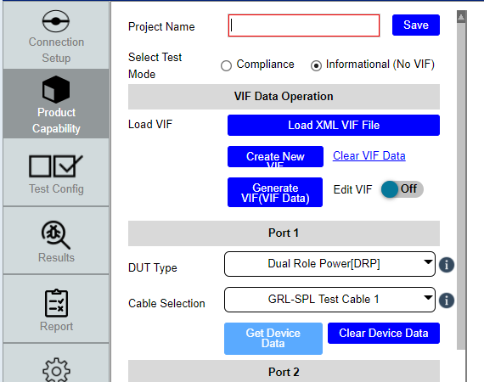

Fig: loading VIF file and selecting the ratio button as informational mode

4 . After loading the VIF file, go to the “Test Configuration” screen and select the “USB-C

Functional Tests” check box button to access full functional tests.

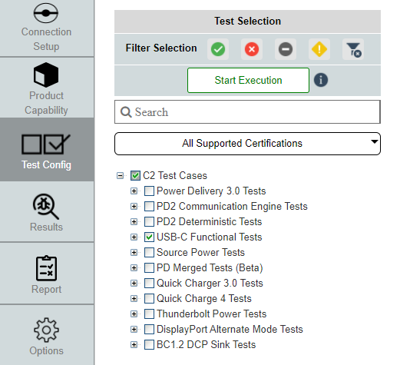

Fig: Functional MOI Selection

If selecting a particular test case, click on the + symbol for an elaborate list of sub test cases.

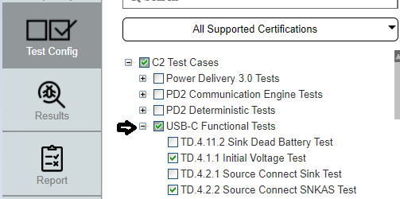

Fig: MOI test selection

After selecting the test cases, select the “Start Execution” button to start running the selected test cases.

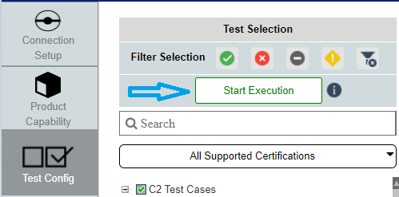

Fig:Start execution

***NOTE: If the VIF based Compliance mode is selected, the “Enable USB 2.0/3.1 data validation” checkbox will be selected by default. To make selecting the checkbox an option, select the Informational Mode instead which will enable test cases to be run without USB data validation.***

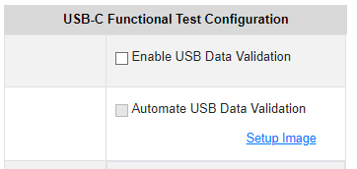

Fig: Disable USB data validation

*5.* The “Results” screen should display all selected functional compliance tests. As tests are running, their progress and status of the test runs will be updated accordingly. The live signal trace plot can be viewed next to the test list. The “Live” icon on the top right corner indicates the test is running in the real-time or offline mode.

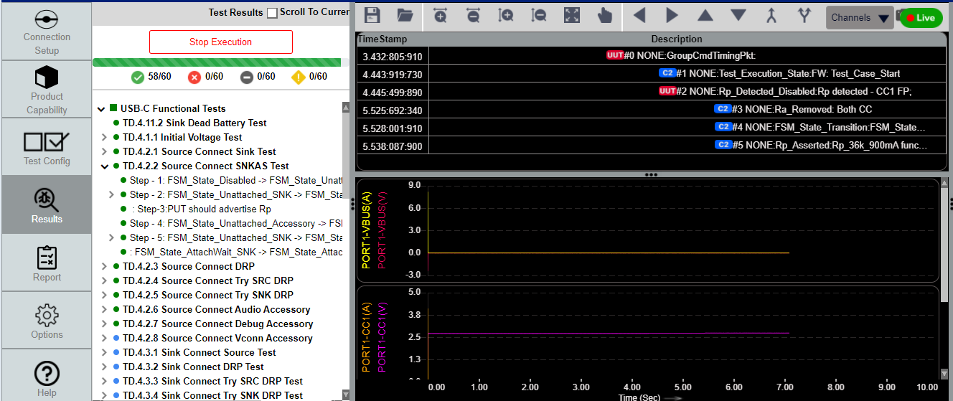

Fig:test case execution

1. To stop the test run while in progress, select the “Stop Execution” button on the Results panel.

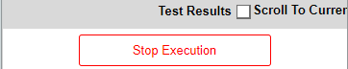

Fig:Stop execution in middle of run

To quickly navigate to the test case that is currently running, click on the **Scroll To Current Test** button.

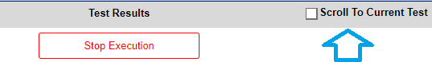

Fig:Jump to the running test case

7 . After the test run has completed, go to the “Report” tab to download/ view the test results.

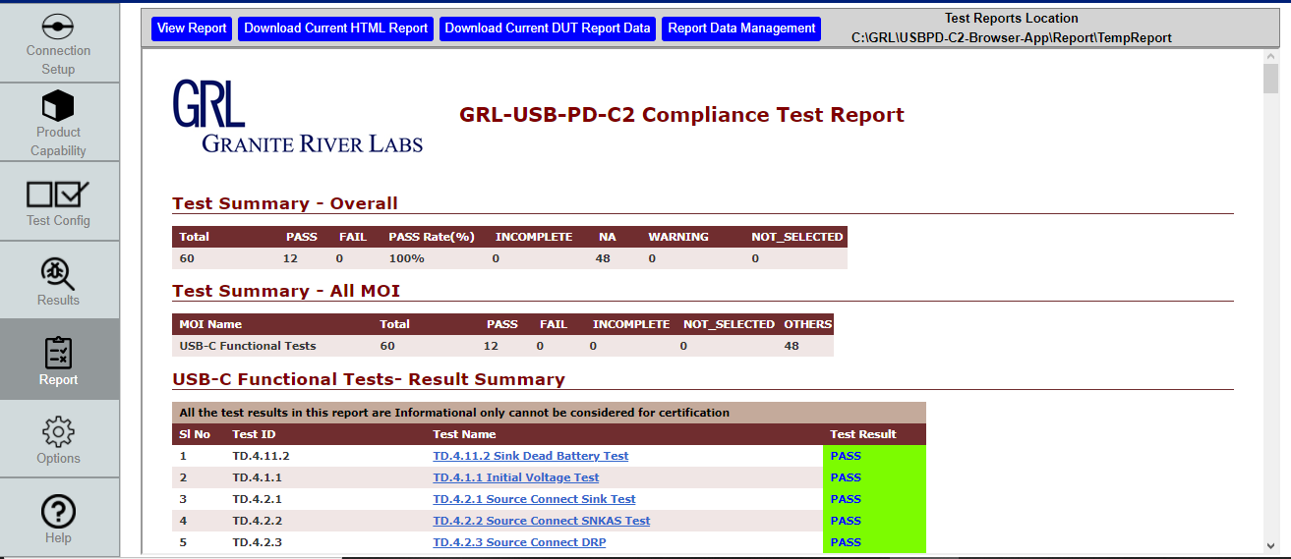

Fig: Report tab

**View Report** button: Jump to the beginning of the report.

**Download Current HTML Report** button: Save the test report in HTML format. The user can also edit the HTML report file name.

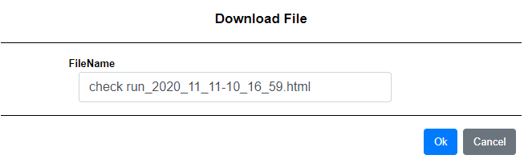

Fig: current HTML download option

**Download Current DUT Report Data** button: Save all the result information to a ZIP folder. The ZIP file can also be renamed as desired.



Fig: current Report download option

**Report Data Management** button: Access other test reports including from previous test runs. This allows you to delete or save the reports as desired from the database.

All test reports will be stored in the following location “**C:\GRL\USBPD-C2-Browser-App\Report\TempReport**”.

***Note:*** *Once the report is deleted via Report Data Management, it will be permanently deleted from the TempReport location.*

**5.2 USB Data Validation:**

The following procedure explains how to perform functional compliance testing with USB data validation enabled. If *USB_Comms_Capable* is set to “YES” in the VIF field:



Fig: VIF field option

1 . Connect the equipment for USB DATA VALIDATION TEST SETUP. (4.3. USB data validation setup)

2 . Open the GRL-C2 Browser App software and connect to the GRL-USB-PD-C2 test controller. For

details on using the GRL-C2 software, refer to http://graniteriverlabs.com/download-center.

3 . Go to the “Product Capability” screen, load the VIF file of the UUT and enter the project name. *[Note: A VIF file is required to ensure proper execution for all test cases, which otherwise most test runs may render incomplete without a VIF file.]*

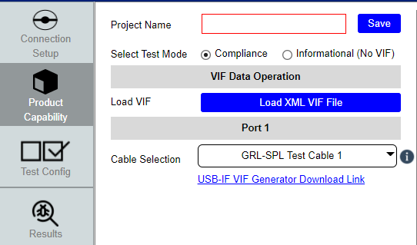

Fig: loading VIF file and selecting the ratio button as Compliance mode

4 . After loading the VIF file, go to the “Test Configuration” screen and select the “USB-C

Functional Tests” check box button to access full functional tests.



Fig: Functional MOI Selection

If selecting a particular test case, click on the + symbol to view the elaborate list of test cases.



Fig: MOI test selection

After selecting the test cases, select the Start Execution button to start running the selected test cases.



Fig:Start execution

The test execution must be carried out in the **Compliance Mode** only to ensure that the USB data validation gets updated based on the VIF file automatically. If not, the USB Data Validation checkbox will be disabled which will cause the tests to execute as normal test runs only.

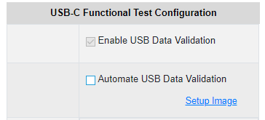 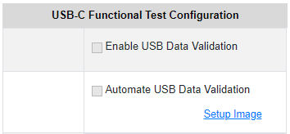Fig: VIF support - USB data validation enabled Fig: No VIF support - USB data validation disabled

**5.2.1.Test Methods**

The test methods are described in the following sections to verify for USB Type-C High-Speed Functional on CTS Functional MOI:

• Manual USB 2.0/3.1 data validation *[manual enumeration check is required]*

**5.2.1.1 - Manual USB 2.0/3.1 data validation:**

1 . Make sure the Automate USB Data Validation check box is not enabled.

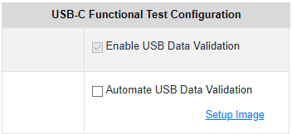

Fig: automation is disabled.

2 . Once the test cases start running, the following screen will appear to check for Enumeration

status of the good-known device (GKD).

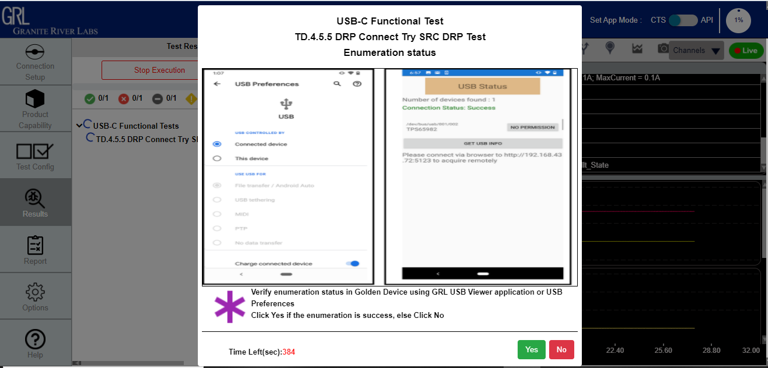

Fig: Enumeration check for successful pop-up

3 . If the UUT is a Source device, the enumeration needs to be validated in the UUT’s Device

Manager, and if the UUT is a Sink device the enumeration needs to be validated in the GKD. If so, click “Yes” to proceed or otherwise click “No”.

4 . If the GKD is enumerating correctly, the next following screen will appear to verify if the enumeration has been ceased. If so, click “Yes” to proceed or otherwise click “No”.

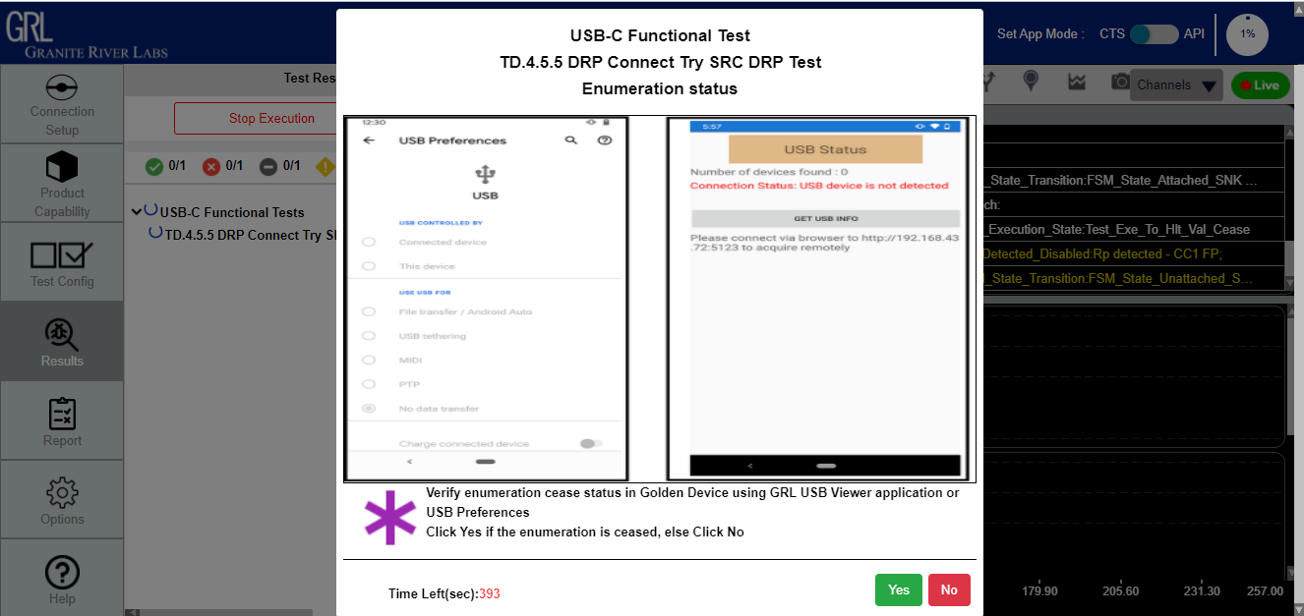

Fig: Enumeration ceased pop-up

**6-Test case pop-ups:**

When running functional compliance tests, certain test cases will require user input to proceed

further. User input will be prompted through pop-up messages for the following test cases:

a. Test Case **TD.4.1.1 Initial Voltage Test** ‒ If the “Enable USB data validation” check box is selected, the pop-up message for this test case requires the user to connect the UUT directly to Port 1 of the GRL-USB-PD-C2 test controller without any fixture or extension board attached. After the test case has been

executed, another pop-up message will appear, which will ask the user to connect to an older FCB setup.

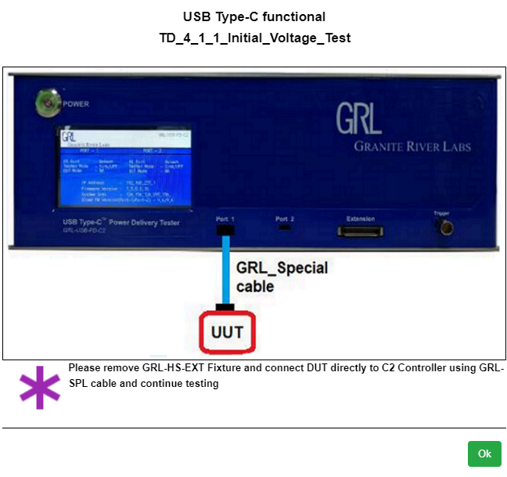 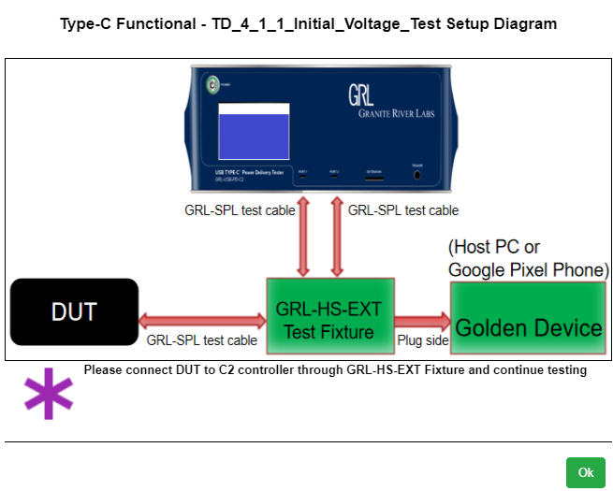

b . Test Case **TD.4.1.2 Unpowered CC Voltage Test** ‒ While test is running, the user will be

required to remove the UUT power. After the test run has completed, the user will then need to re-connect power supply to the UUT.

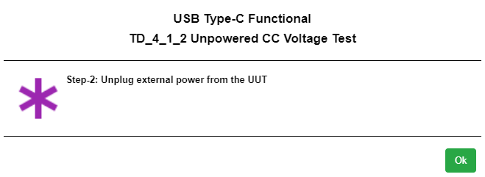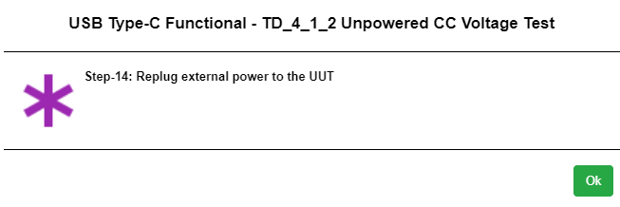

C . Test Case **TD.4.5.4 DRP Connect DRP Test**, **TD.4.6.3 Try SRC DRP Connect Try SRC DRP Test** and **TD.4.7.2 Try SNK DRP Connect Try SNK DRP Test** ‒ These test cases are categorized under Regression Tests. At the beginning of test run, a pop-up message will require the user to connect the VBUS Extension board (GRL-C2-Functional-BRD functional board, GRL-C2-IO-EXT6 extension board and EXT6-IO-Cable test cable)

based on the Regression Test setup. Select “Yes” if the hardware is properly set up or “No” if otherwise. After the test run has completed, the user will be required to remove the VBUS Extension board and to proceed with the General Test setup to continue testing.

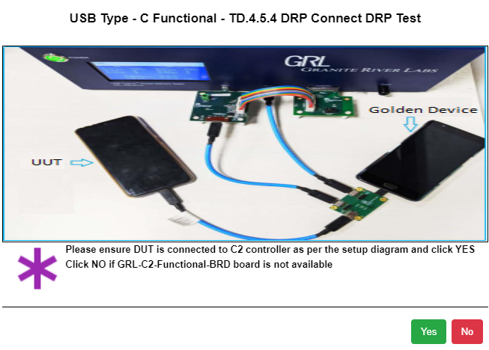

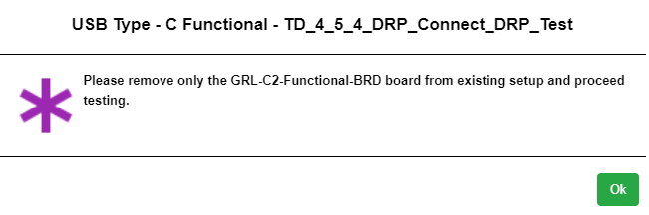

D . Test Case **TD.4.9.1 Source Suspend Test** ‒ After successful enumeration in compliance to

CTS requirements, the user will be required to suspend the UUT high-speed link. When done, select “Yes” to proceed or “No” if otherwise. After the test run has completed, the user will then be required to resume the UUT high-speed link. Again select “Yes” when done or otherwise select “No”.

E. Test Case **TD.4.11.2 Sink Dead Battery Test** ‒ This test case checks if the battery of the

UUT is dead or 0% charged. The user will first need to check whether or not a battery is

connected to the UUT in the Test Config Tab. Enable the check box if a battery is attached.

If a battery is attached, A pop-up message will ask to verify the UUT Dead battery is connected. Select “Yes” to proceed with the verification test or otherwise select “No. Once a dead

battery has been verified, the user will then be required to remove the dead battery and replace

with a charged battery for testing to continue.

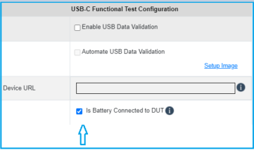 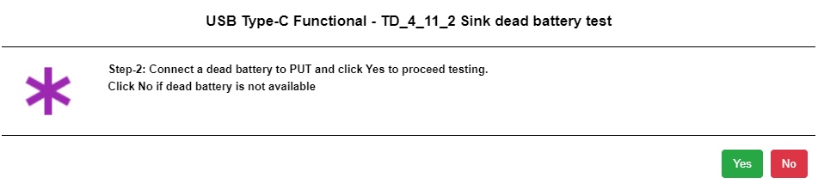

Fig. Battery check Fig. Dead battery connection pop-up

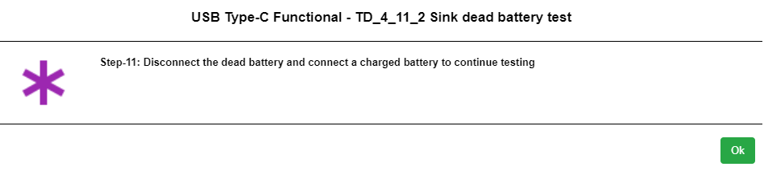

Fig. User needs to connect the charged battery again.

F . Test Case **TD.4.12.2 Hub Port Type Test** ‒ This test case is only applicable when the UUT

*Type_C_Port_On_Hub* is set to “YES” in the VIF. The user will first need to check whether or not the hub port is embedded in the Test Config tab. The user will need to provide input regarding the number of USB Type-C ports & number of USB Type-B/Micro-B receptacle or Type-A plug when UFP = 0 in the Test Config tab.

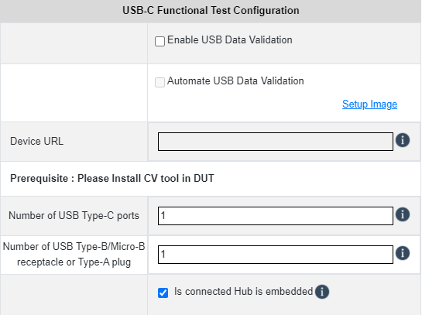

1. **CV tool usage:**

7.1 Test case 4.10.1 CV tool steps

7.2 Test case 4.10.2 CV tool steps

7.3 Test case 4.10.3 CV tool steps

Follow the steps below on using the CV Tool:

1. Open the USB 3 Gen x CV and the “Command Verifier” pop-up message will appear. Select the required host controller from the list to load the test stack switch and then select “Continue”. Wait until the stack switch is loaded. Where necessary the user may also need to reboot the GKD if prompted.
2. If rebooting the GKD, open the USB 3 Gen x CV again after reboot and repeat step i.

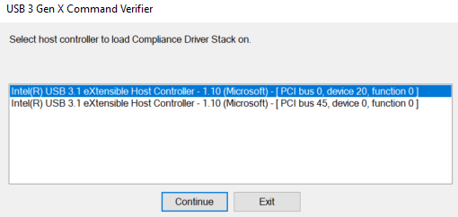

Fig Host controller selection

iii. The following steps will be based on the selected test case:

**7.1. Test case 4.10.1 CV tool steps:**

Perform the following steps for the 4.10.1 test case:

a. In the **Select Test Suite** field, select “Chapter 9 Tests [USB 2 devices]”.

b. In the **Select Test Mode** field, select the “Debug” radio button.

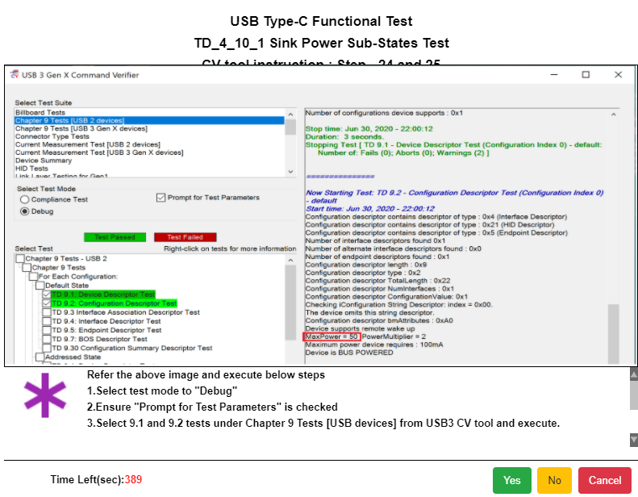

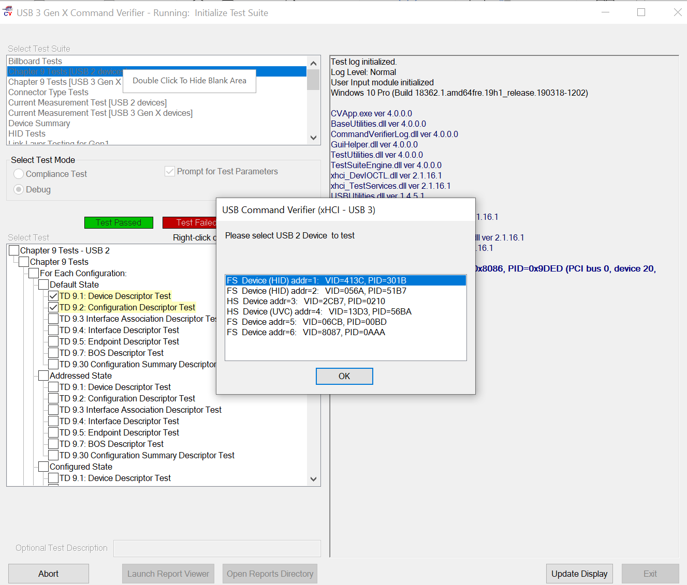

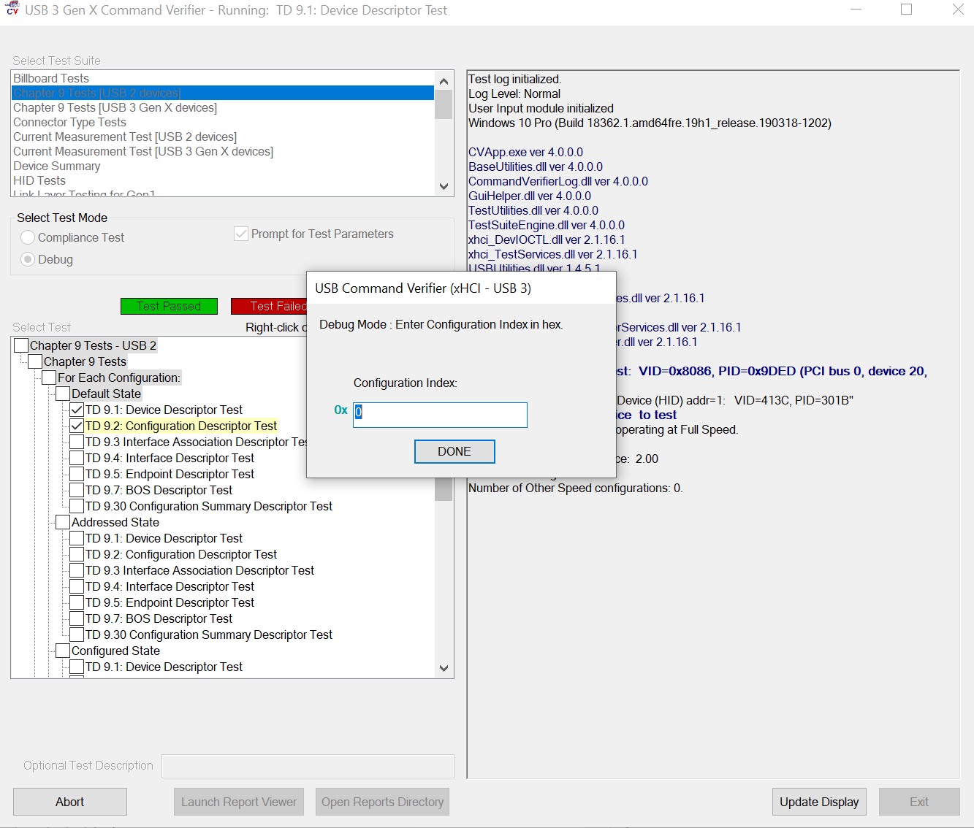

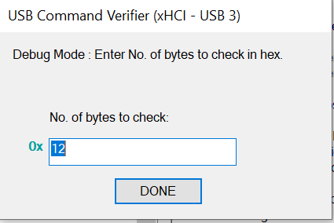

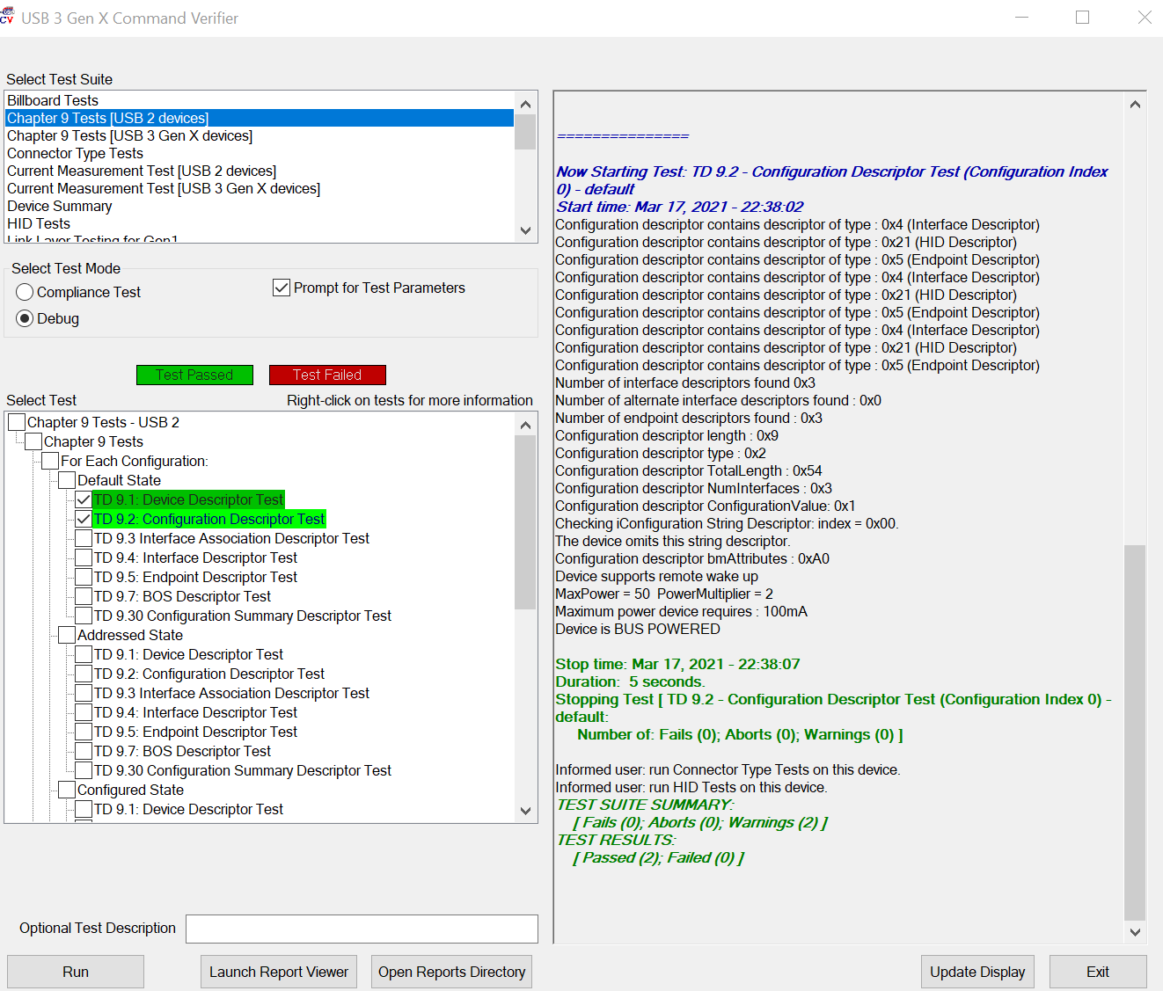

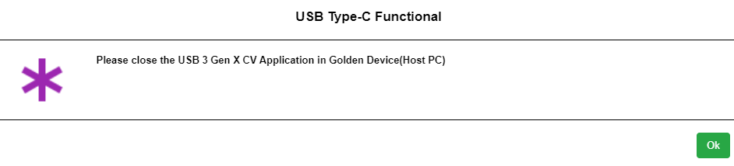

**7.2 Test case 4.10.2 CV tool steps:**

Perform the following steps for the 4.10.2 test case:

a. In the **Select Test Suite** field, select “Chapter 9 Tests [USB 2 devices]”.

b. In the **Select Test Mode** field, select the “Debug” radio button.

c. In the **Select Test** field, select the “TD 9.16: Enumeration Test” checkbox.

d. Finally, select the bottom “Run” button to execute the Enumeration test.

E. While test is running, the “USB Command Verifier (xHCI- USB 3)” pop-up message will display a list of FS devices. Select the FS device as supported by the UUT and select “OK”.

F. In the next pop-up message (Figure 5.36 below), the user will need to enter the required enumeration loop count for Debug mode and select “DONE”. This will update the status on the GRL-C2 Browser App pop-up message.

*[Note: 10 is the preferred count].*

G.When the “USB 3 Gen X Command Verifier” window appears, perform the following steps:

H. In the **Select Test Suite** field, select “Chapter 9 Tests [USB 2 devices]”.

I. In the **Select Test Mode** field, select the “Debug” radio button.

J. In the **Select Test** field, select the “TD 9.13: Set Configuration Test” checkbox.

K. Finally, select the bottom “Run” button to execute the Set Configuration test.

L. While test is running, the “USB Command Verifier (xHCI- USB 3)” pop-up message will display a list of FS Devices (Figure 5.40 below). Select the FS Device as supported by the UUT and select “OK”.

M. In the next pop-up message (Figure 5.41 below), the user will need to enter the appropriate Configuration Index value in hex for Debug mode and then select “DONE”. This will update the status on the GRL-C2 Browser App pop-up message.

N. If the test Fails or the user selects “Cancel” in the pop-up message, the user will be required to perform CTS “TD 7.40 Warm Reset” test as prompted by the following pop-up message on the GRL-USB-PDC2 test controller. Once done, the status will be updated on the GRL-C2 Browser App pop-up message.

O. When the “USB 3 Gen X Command Verifier” window appears (Figure 5.44 below), perform the following steps:

a. In the **Select Test Suite** field, select “Link Layer Testing for Gen2”.

b. In the **Select Test Mode** field, select the “Debug” radio button.

c. In the **Select Test** field, select the “TD 7.40 Warm Reset” checkbox.

d. Finally, select the bottom “Run” button to execute the Warm Reset test.

P. While test is running, the user will be asked to confirm warm reset to be carried out on the UUT. Select “OK” to proceed. This will update the status on the GRL-C2 Browser App pop-up message.

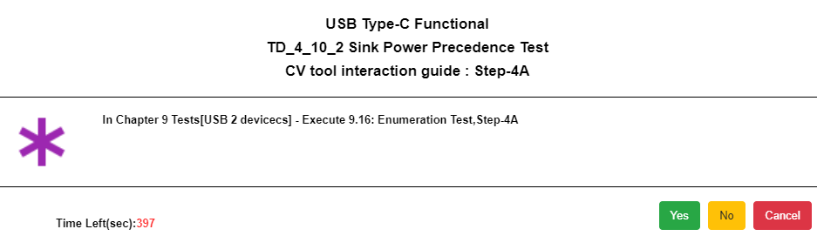

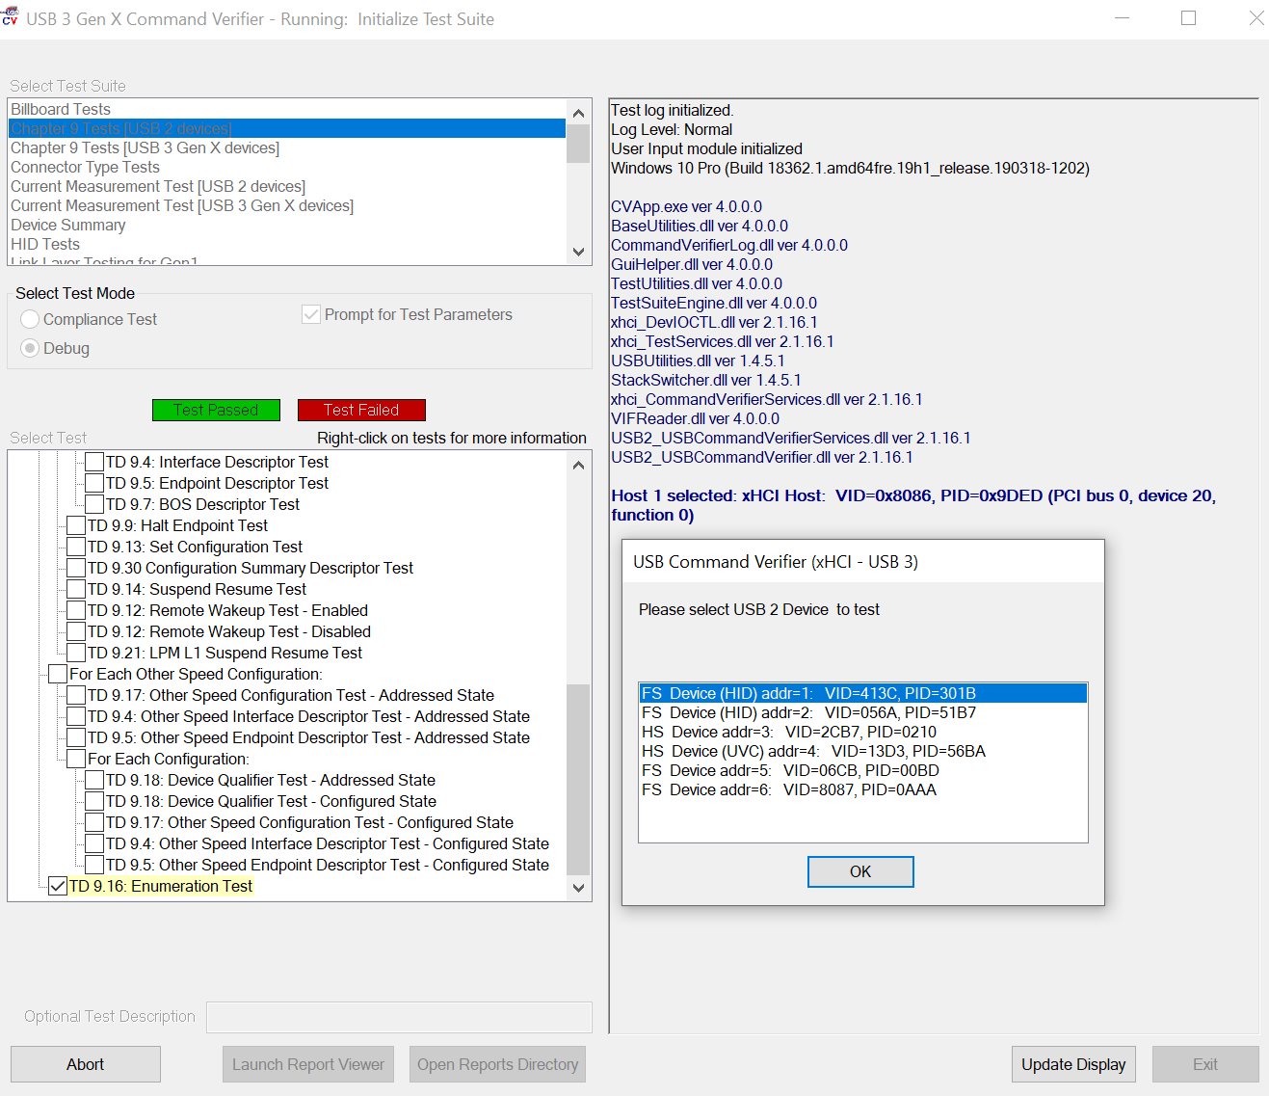

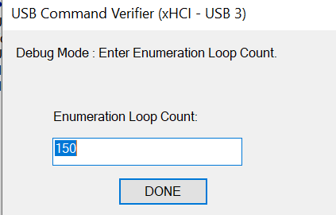

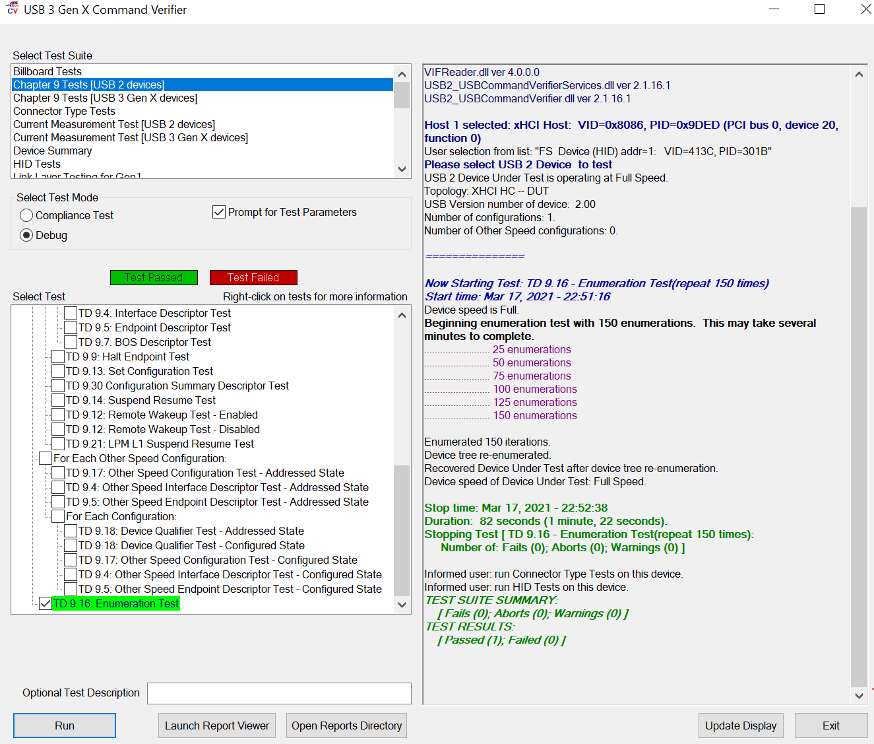

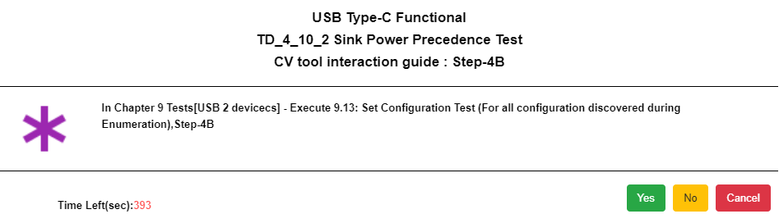

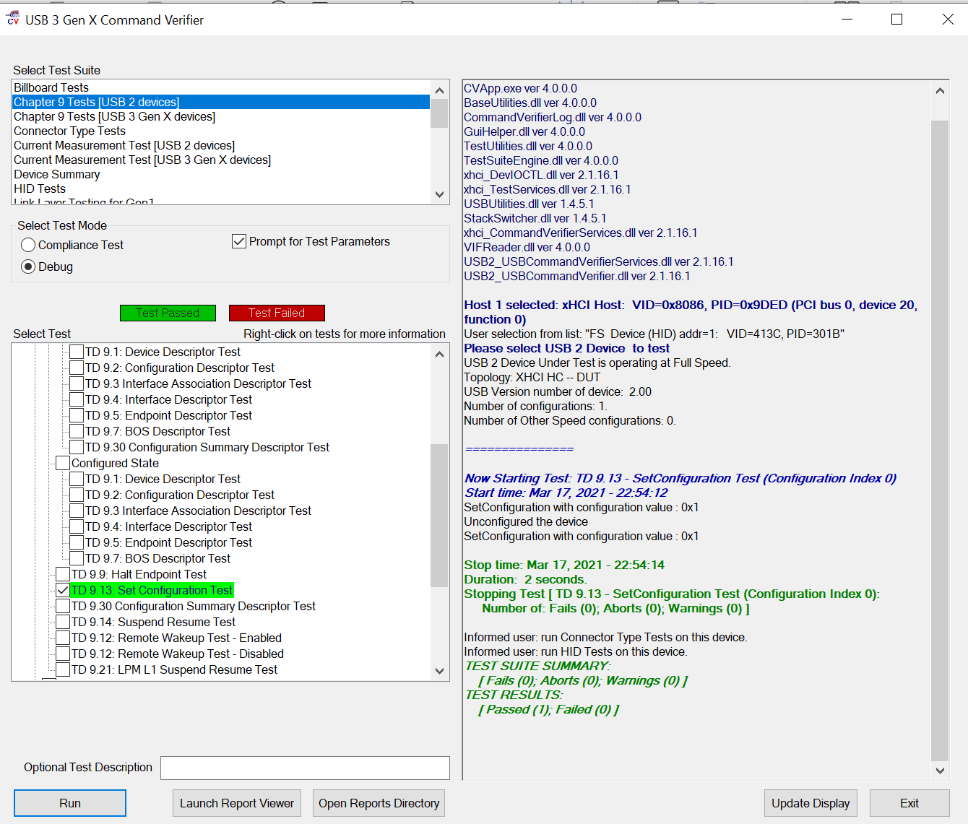

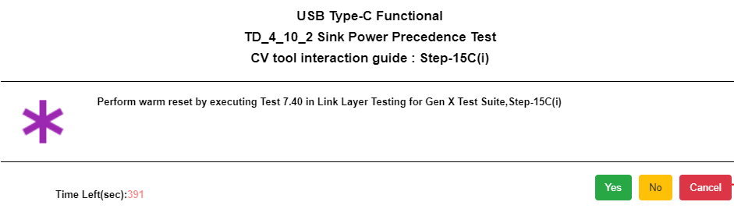

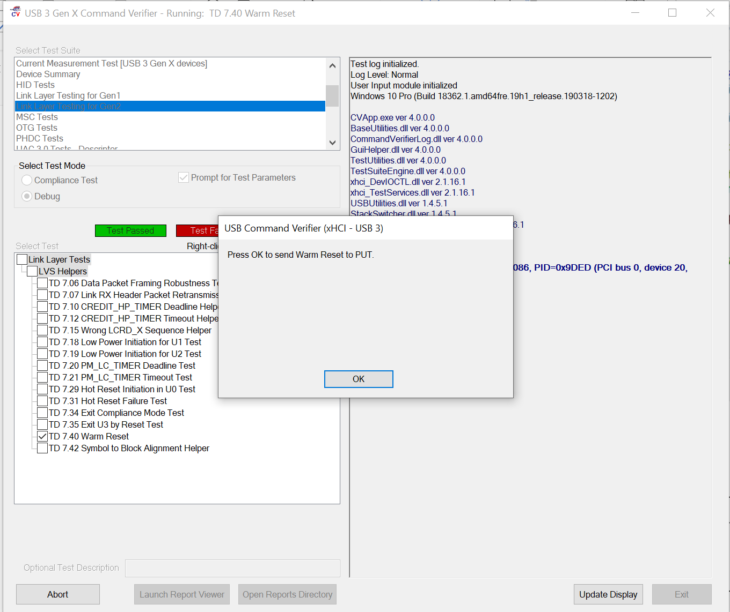

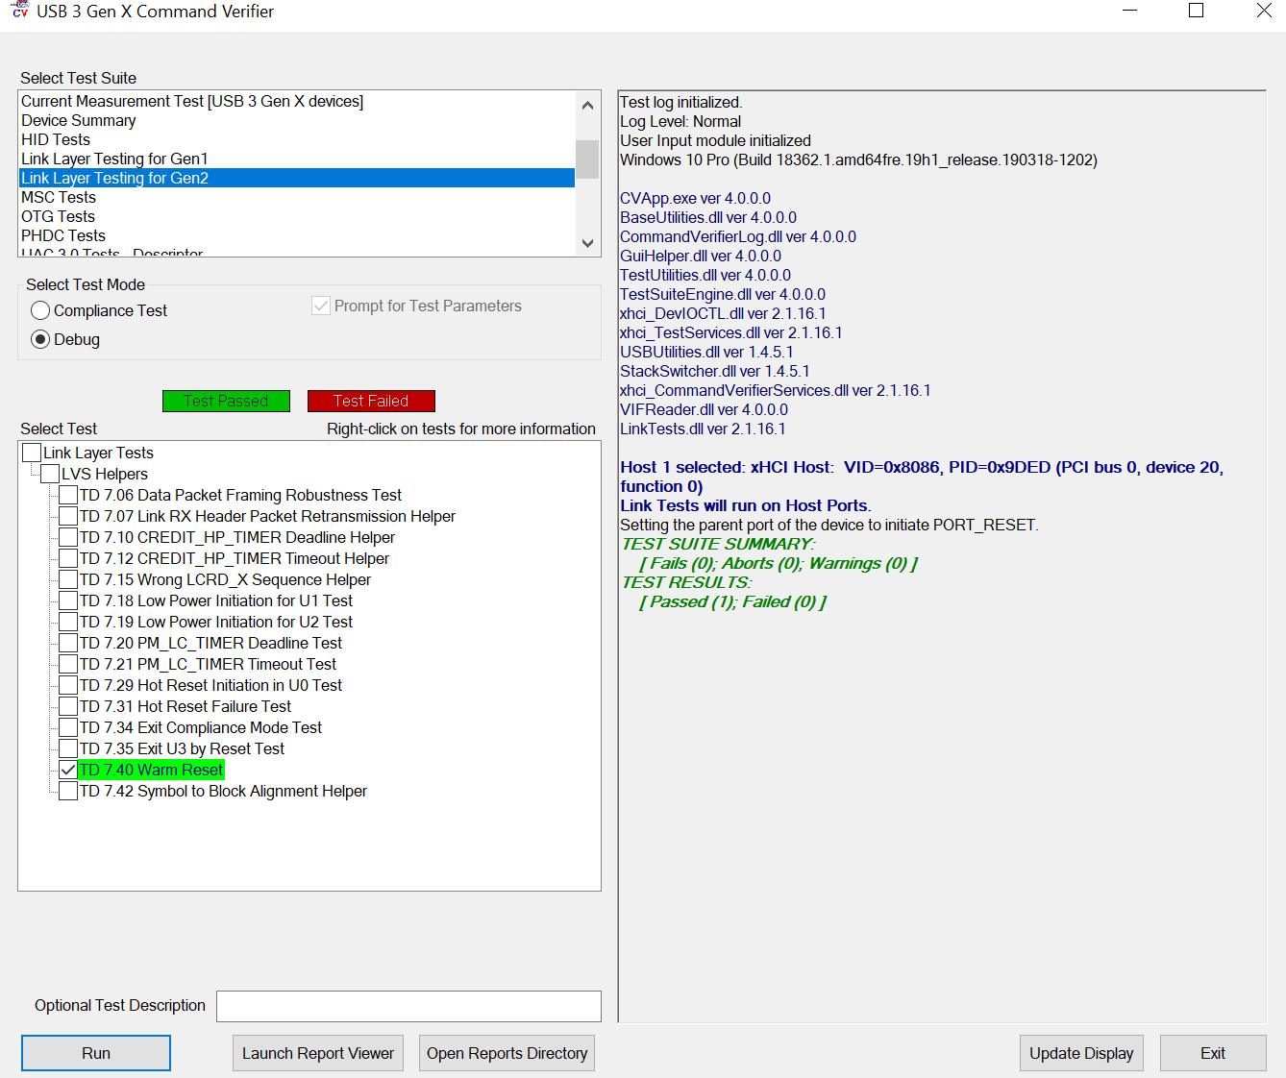

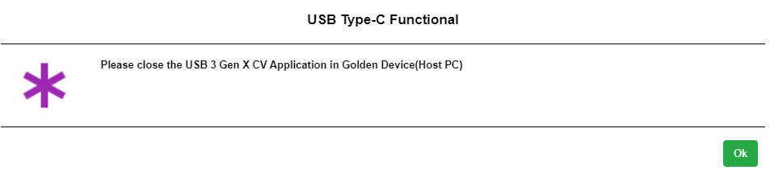

**7.3 Test case 4.10.3 CV tool steps:**

The following 4.10.3 test case is based on the device USB type.

7.3.1 USB 3 device.

7.3.2 USB 2.0 device.

Perform the following steps for the 4.10.3 test case:

a. In the **Select Test Suite** field, select “Current Measurement Test [USB 3 Gen X devices]”.

b. In the **Select Test Mode** field, select the “Debug” radio button.

c. In the **Select Test** field, select the “Enter Suspend (U3)” checkbox.

d. Finally, select the bottom “Run” button to execute the Suspend UUT Link test.

